**A Matterport-based Integrated Virtual Laboratory Environment for Engineering Students**

Lau Zi Rui*, a, Robin Tan a, Endu Tee b

a School of Engineering, Ngee Ann Polytechnic, Singapore

b Centre for Learning & Teaching Excellence, Ngee Ann Polytechnic, Singapore

*Lau_Zirui@np.edu.sg

**Abstract**

**Given the emergence of technological advancements like the Internet of Things (IoT), Artificial Intelligence, Augmented and Virtual Reality, it is imperative for engineering education to keep up with industry demands. To achieve this, one promising approach is the utilization of virtual labs. These labs provide students with practical training in a simulated environment, which enables them to acquire hands-on experience. In this paper, the authors proposed the use of Matterport, a 3D camera and virtual tour platform, to create a virtual lab environment for Year 1 Engineering students in Ngee Ann Polytechnic. Matterport's ability to create highly detailed and accurate 3D models of physical spaces makes it an ideal tool for building virtual labs. More specifically, a virtual environment of a Thermofluid lab was created, focusing on the perfect gas expansion equipment. The lab equipment in the virtual environment was furnished with instructional videos and simulation data to enhance interactivity.**

**The virtual environment provides students with access to the perfect gas expansion experiment and offers the advantage of enabling students to conduct "risky" experiments such as gas expansion without any danger. Additionally, the virtual lab and its equipment are available 24/7, which provides opportunities for students to practice and learn at their own pace and time. This benefit was particularly valuable during the campus closure due to the COVID pandemic. Another advantage of virtual labs is that they reduce the need for physical space and associated equipment maintenance.**

**The Matterport virtual lab was used as a substitute for in-person instructor-led lab for peri-corona home-based learning and as a supplementary learning resource for post-corona hybrid learning. To evaluate the efficacy of the Matterport virtual lab, the authors conducted a comparative analysis of students’ laboratory performance results for three different semesters (pre-corona, peri-corona, and post-corona periods) involving cohorts of 400 students each. There was only a 4.3% deviation in the mean and median laboratory scores between the pre-corona and peri-corona results, indicating that students achieved similar learning outcomes and competencies while completing the perfect gas experiment solely through the virtual lab during peri-corona as compared to in-person instructor-led lab during pre-corona. Based on the same metrics, it was also observed that the post-corona results showed a 7.36% improvement compared to pre-corona results. This suggests that students were able to effectively use the virtual lab as a supplementary learning resource to enhance their learning. Furthermore, an evaluation survey conducted with the students revealed that on average, each student spent an extra 28.5 minutes on the virtual lab in addition to the 1-hour instructor-led experiment weekly. The 47.5% increase in time spent by each student in the lab during post-corona as compared to pre-corona may have contributed to the observed improvement in grades. These findings indicate that virtual labs have the potential to be an effective and efficient alternative to traditional face-to-face labs. Additionally, they serve as a flipped learning and recap tool that extends students’ learning, thus offering possibilities for enhancing engineering education.**

**Keywords:** *Engineering education, virtual labs, Matterport, 3D camera, virtual tour platform, simulated environment, Thermofluid lab, perfect gas expansion equipment, post-corona era.*

**Introduction**

The global COVID-19 pandemic has disrupted conventional education practices, including laboratory-based engineering learning. The implementation of physical distancing measures and the shift towards remote or online learning by many educational institutions has limited students' access to traditional laboratory facilities. As a result, there is a growing demand for virtual lab environments that can replicate hands-on learning experiences while ensuring safety and accessibility. Various technologies, such as Matterport (Rauch et al, 2021), Labster (Shady et al, 2021), and Virtual Lab, can be employed to create digital models of physical spaces for virtual lab simulations. Jeschke et al. (2007) have demonstrated that these virtual lab environments enable students to virtually tour real-world engineering projects or sites, facilitating exploration and analysis of designs and structures in ways that were not possible through traditional methods, such as photographs or drawings. Furthermore, to stay relevant and competitive in the rapidly evolving technological landscape, it is crucial for engineering education to remain up to date with emerging industry trends. With advancements like the Internet of Things (IoT), Artificial Intelligence (AI), and Augmented and Virtual Reality (AR/VR), it is imperative that students are adequately prepared to meet the demands of the modern workplace. To achieve this, one approach is to provide students with practical experience working with these technologies through simulated environments such as virtual labs. This can equip students with the necessary skills and knowledge to excel in their careers and contribute to the advancement of these fields. The aim is to ensure that graduates are well-equipped to handle the challenges of the industry and stay up to date with emerging trends.

**Literature Review**

Studies have shown that the use of virtual labs, created with Matterport or similar, can be an effective way to enhance student learning and engagement in engineering education. For example, Baher J. (1998) implemented CyclePad, a versatile virtual lab, in thermodynamics courses across three schools. Students reported improved understanding of thermodynamics, acquisition of problem-solving techniques, and ease in performing calculations through the use of CyclePad. Instructors could assign more realistic problems compared to traditional textbook exercises. Similarly, Chu K. C. (1999) found that virtual labs save time and help students learn basic and advanced concepts through remote experimentation. As the adoption of virtual labs has increased, recent technology tools have been developed to enhance the immersive learning experience. For instance, Cave Automatic Virtual Environments (CAVE) and Head Mount Displays (HMD) described by Freina et al. (2015) are considered expensive and not easily available to many students. Therefore, Robertson et al. (1993) introduced non-immersive VR (Virtual Reality), which places the user in a 3D environment behind a conventional graphics workstation, while providing the user with the ability to interact with the 3D environment through various audiovisuals. Non-immersive VR can be captured by 360 cameras, which have become affordable to the consumer market in recent years, as mentioned by Wolf et al. (2021). Matterport, a 3D scanning technology, is one of such platforms which can be used to provide such non-immersive VR experience. It was originally developed for the real estate industry, but it has found its innovation footing in education. In engineering education, it can provide students with virtual tours of real-world engineering projects or sites, engineering workplaces, and labs. This enables them to explore and analyze designs and structures that are richer in content than traditional methods such as photographs or drawings. In this paper we shall consider its application in the development of a virtual lab. The incorporation of virtual labs into engineering education has the potential to enhance student engagement, deepen understanding of concepts and principles, provide cost-effective access to real-world engineering projects without the need for costly field trips, and promote safety through simulation of scenarios when safety is not adhered to. For instance, Bell and Fogler (2004) applied virtual reality (VR) to chemical engineering education and highlighted the consequences of improper safety procedures in a controlled virtual environment.

**Development and Implementation**

Development of 3D Matterport virtual lab

The initial step in developing the virtual laboratory involved identifying a suitable physical experiment for converting it to virtual experiment. Given the study's preliminary nature, the experiment's simplicity was a key consideration in selecting suitable experiments to be converted to virtual experiments. Consequently, the isothermal gas expansion lab was chosen due to its straightforward equipment setup and the fact that only 50% of the drawn conclusion requires the collection of experimental data, with the remaining portion relying on theoretical calculations. The objective of the isothermal gas expansion lab is to investigate and validate the Characteristic Gas equation. Students are tasked with recording initial and final pressure and temperature values of a chamber which undergoes a pressurized air expansion. The final pressure and temperature values will serve as the experimental results which shall be compared alongside a theoretical set of results. The theoretical set of results is calculated by utilizing the Characteristic Gas equation (1) with the initial pressure and temperature as inputs. The expected result of this experiment includes a deviation between the experimental and theoretical results which requires the students to comment on the effect of irreversibility during the expansion process which contributed to the deviation.

|  |  |
| --- | --- |
| $$pV=mRT$$ | (1) |

Where,

p: Pressure (Pa)

V: Volume ($m^{3}$)

m: Mass (kg)

R: Gas constant (J/kgK)

T: Temperature (K)

To create an immersive virtual lab, the Matterport Pro2 3D Camera proves to be an invaluable tool. With its high-quality 4K resolution capture and cutting-edge infrared technology, it allows for detailed scanning of an engineering lab (Figure 1). The resulting virtual lab (Figure 2) provides students with remote access and exploration of the equipment and experiments in unprecedented ways that traditional methods such as photographs or drawings simply cannot replicate. The Matterport Pro2 3D Camera offers some key features that enhance the virtual lab experience. Its 360° views and spherical images enable students to view the lab from all angles, providing a truly immersive experience. The automated generation of color 2D and 3D interactive floor plans adds a new dimension to understanding the lab layout and equipment placement. The camera captures 3D scans with remarkable accuracy, ensuring that the virtual lab is an accurate representation of the real-world lab.

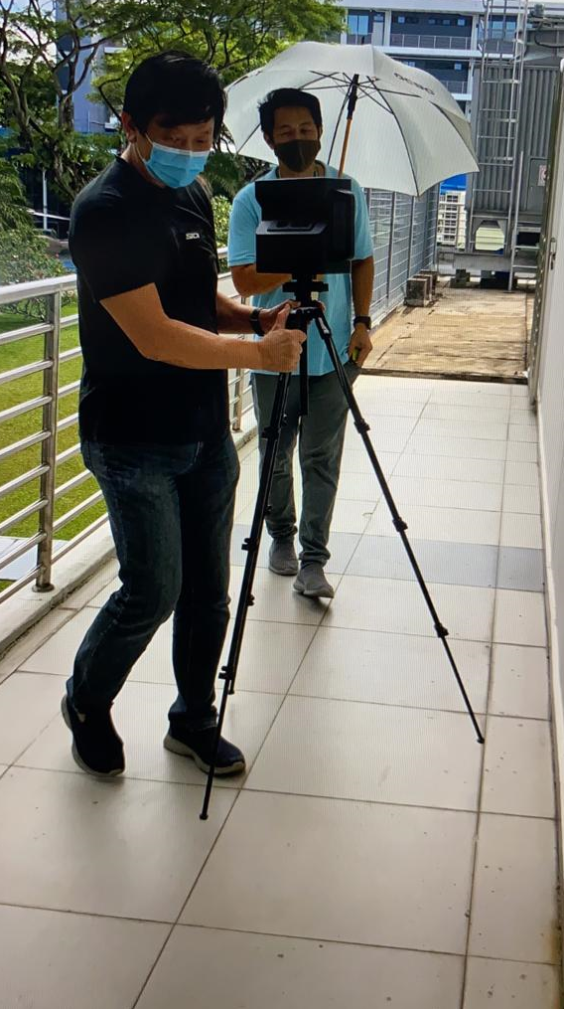

Figure 1:Matterport 3D camera scanning

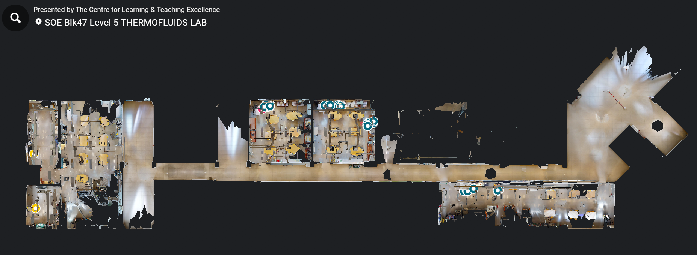

Figure 2: 3D scan of School of Engineering Thermofluids lab

Other than providing a digital replica of the lab, the Matterport platform also allows for a more interactive form of learning. One feature is the ability for learners to perform annotations on the equipment in the virtual environment. These annotations allow them to understand the uses and functionality of each part of the equipment.

Videos can also be embedded within the environment to enhance the learning experience. For the isothermal experiment presented in this paper, two sets of instructor-led teaching videos and one set of simulation results were embedded within the environment. The teaching videos provide students with visual and auditory explanations of the equipment and perfect gas theory used in the experiment. In the era of post-corona hybrid learning, where students have access to both digital and physical platforms of learning, such videos can be particularly useful for students who learn more effectively through visual aids, and students can also replay them to capture relevant information that might have been missed during the physical lesson. In addition, simulation results or visuals were obtained by simulating the isothermal expansion process using SolidWorks software. The simulation is particularly useful for this experiment as it allows learners to visualize how the air particles expand from the pressurized chamber to the occupy the secondary chamber, which would be impossible in a real-life demonstration as air molecules are invisible to the naked eye. The simulation results also enable students to see the predicted outcomes of the experiment and compare them with their own results, helping them to identify and correct any errors in their experimental setup. This allows for a deeper understanding of the experimental procedure and the underlying thermodynamic principles of the isothermal expansion process

(a)

(b)

(c)

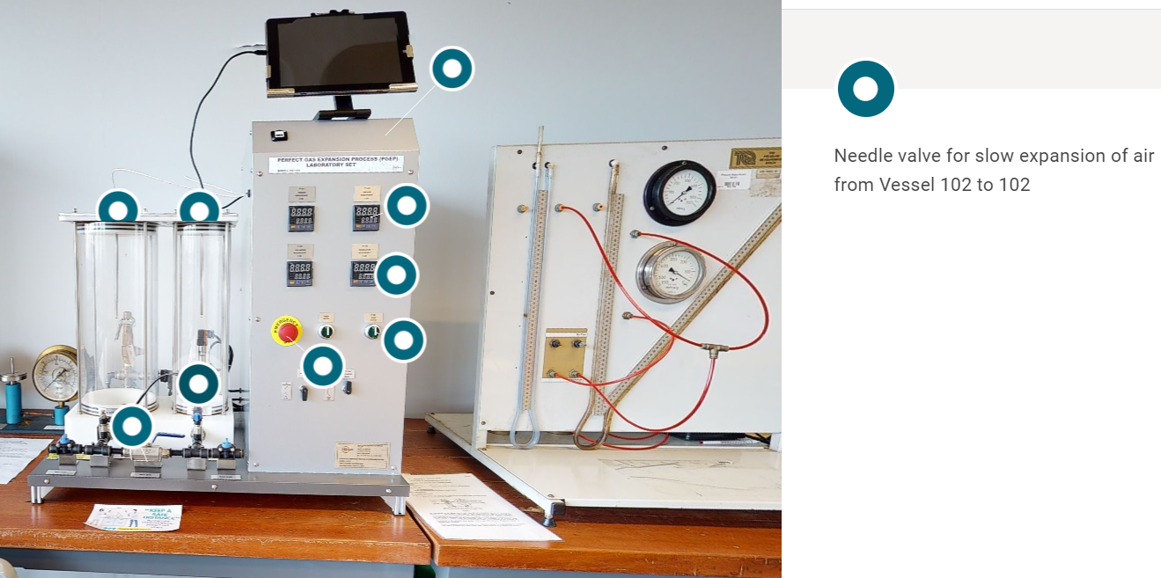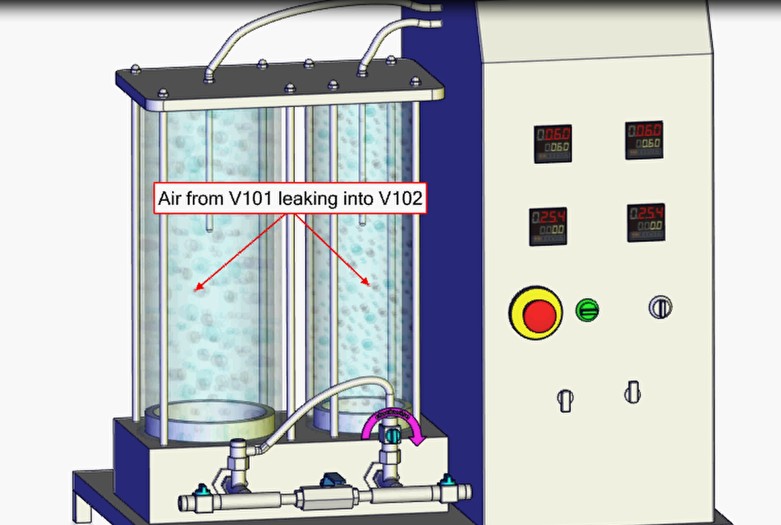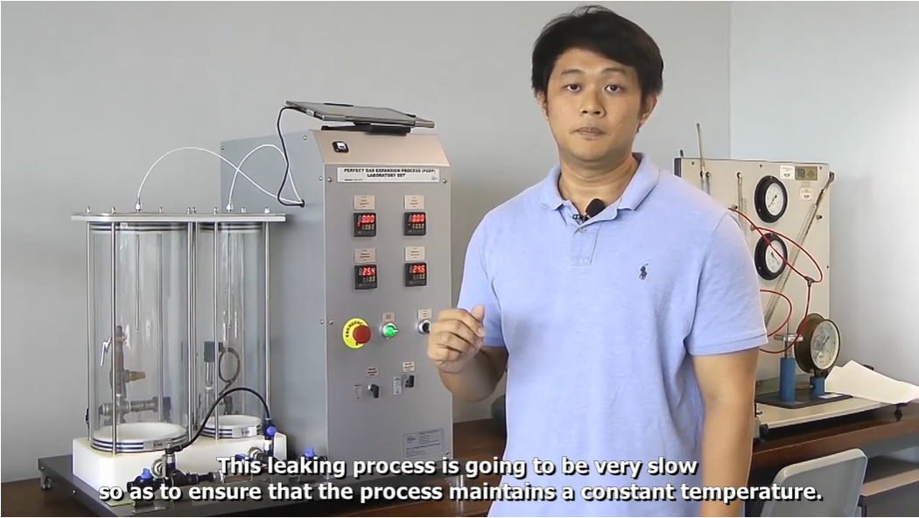

Figure 3: Features of the virtual lab- (a)Equipment annotation; (b)Simulation; (c) Instructional video

Implementation of 3D Matterport virtual lab

The virtual lab was initially implemented during the peri-Covid period when students were not allowed to return to campus to perform experiments due to the movement control order. With the virtual lab, students were able to access a "life-like" laboratory environment from the safety and comfort of their homes and collected experimental data through the virtual platform, successfully fulfilling academic requirements for their diploma. After the pandemic ended and students were allowed to return to campus, Ngee Ann Polytechnic saw an opportunity to transition its teaching and learning practices from traditional delivery methods to a hybrid approach. One of the major initiatives was the rollout of Online Asynchronous Learning (OAL) for all modules, which is part of a flipped learning pedagogy. The OAL requires students to go through a set of learning activities and videos related to the teaching topic before coming to class. This achieves greater efficiency and effectiveness in terms of face-to-face delivery as students gain foundational knowledge before coming to class, and class sessions can be used to deepen their learning on advanced concepts. With its self-directed and asynchronous learning characteristics, the virtual lab was integrated into the OAL content, providing students with an overview of the lab before attending the physical laboratory sessions. Thus, in the post-Covid period, the virtual lab was successfully deployed as a self-directed flipped learning tool as part of the OAL content, supplementing students' learning in class.

**Results and Discussion**

The analysis of results will be divided into two subparts to examine the effectiveness of the virtual lab in supporting engineering students to complete the perfect gas experiment and its ability to serve as a learning enhancement tool as the school pivots towards post-corona hybrid form of learning. In the first part, the results of a student survey are analyzed to evaluate the effectiveness of the virtual lab as a tool for teaching engineering concepts during the peri-corona and post-corona periods. In addition, individual response and feedback on the virtual lab are examined to sieve out key improvements to be made to future iterations of the virtual lab. The second part of the results analysis will focus on the comparison between three different semesters of students’ laboratory performance results across 3 different periods: pre-, peri- and post-corona. This comparative study aims to assess the virtual lab’s ability to serve as a learning enhancement tool.

Student Survey

The student survey was conducted during the peri- and post-corona periods. The goal of the peri-corona survey was to examine the effectiveness of the virtual lab as an alternative replacement of the physical lab. However, the goal of the post-corona survey was to examine the virtual lab's ability to serve as a learning enhancement tool. The peri-corona survey consisted of one multiple choice question and three Likert scale questions; this survey was posted to a respondent group of 60 students. The results of the peri-corona survey are summarized in Figure 4 and Figure 5.

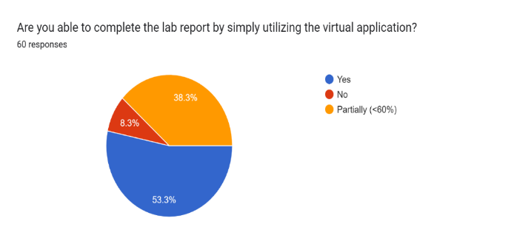

Figure 4: Peri-corona binary question

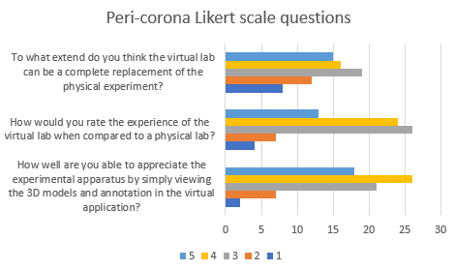

Figure 5: Peri-corona Likert scale questions

Responding to the question on whether the students were able to complete the Perfect Gas Experiment by utilizing the virtual lab alone, 8.3% gave a definite no, 38.3% mentioned that they were able to complete at least 60% of the lab while 53.3% was able to complete the lab work entirely. The “No” option represents students who were entirely not able to do the lab with the information provided by the virtual lab alone while “Yes” indicates that the student is able to complete 100% of the lab sheet by using the virtual lab alone. With regards to the Likert scale questions, where a rating of 5 meant that the student strongly agree to the statement and a rating of 1 indicate a strong disagreement, a median score of 3.08 was achieved when the students were asked if the virtual lab could serve as a complete replacement for the physical lab; a median score of 3.47 was recorded when the students were asked to rate their experience with the virtual lab as compared to a physical lab and a median score of 3.68 was achieved when it comes to understanding the use and application of the lab equipment in virtual formats. Overall, these results indicated a positive acceptance towards the virtual lab and thus, highlights that the virtual lab was effective as a teaching tool during the corona period in which face-to-face delivery teaching methods were restricted.

The post-corona survey consisted of two binary (“yes” or “no”) questions, one Likert scale question (the 1-5 scale is defined the same way as in the peri-corona survey) and one multiple choice question; which was posted to a respondent group of 60 students. The results of the post-corona survey are summarized in Figure 6 and Figure 7 .

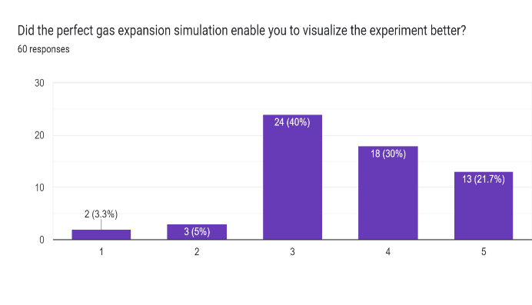

Figure 6:Post-corona Likert scale question

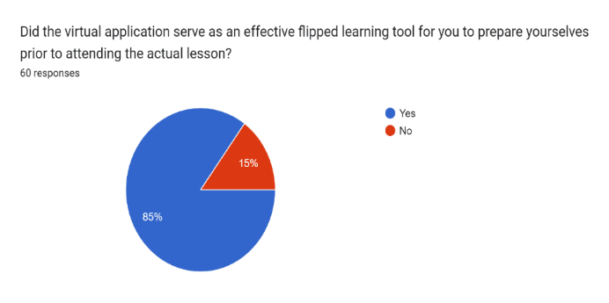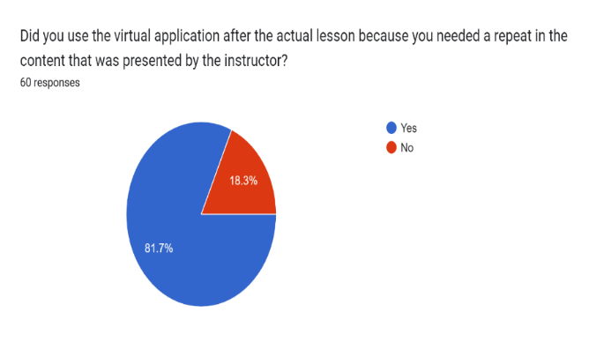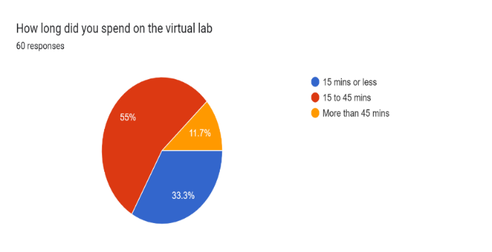

Figure 7:Post-corona survey (binary and multiple choice) questions

Based on the findings extracted from the post-corona survey, a noteworthy observation emerges. Specifically, a significant majority of 85% of the surveyed students expressed that the virtual application, when employed as a flipped learning tool, effectively aided them in preparing for the subsequent in-person lesson. Furthermore, an impressive 81.7% of the students reported utilizing the virtual lab as a recapitulatory resource after the completion of the physical lesson. These compelling results serve to validate the efficacy of the virtual lab as a suitable tool for augmenting students' learning experiences, while also serving as a supplementary resource to traditional face-to-face instructor-led laboratories.

On top of the structured survey responses, open-ended questions were also posted to the students to seek their direct feedback and opinion on the virtual lab. The student responses highlighted several areas for improvement in the virtual lab. These include addressing issues related to lag and connectivity, enhancing the sensitivity (to user inputs) of the virtual lab, providing heads-up for upcoming experiments or work, improving clarity of instructions and explanations, supplementing with more information such as videos, equations, and instructions, offering a feature to ask questions or seek clarification during the virtual lab, and ensuring a convenient and straightforward user experience. Furthermore, students emphasized that physical labs are still preferred for real-life exposure and hands-on interaction with apparatus, and that the virtual lab can serve as a supplemental resource for reference and reinforcement of learning. Overall, the feedback suggests the need for continuous improvement in the virtual lab to enhance its usability, interactivity, and effectiveness as a learning tool.

Semester on semester laboratory comparison

To evaluate the efficacy of the Matterport virtual lab as a substitute for face-to-face instructor-led laboratory experiments and as an enhancement tool for post-corona hybrid learning, we conducted a comparative analysis of laboratory results for three different semesters involving cohorts of 400 students each. The analysis was conducted for pre-, peri- and post-corona periods. We found a 4.3% deviation in the mean and median laboratory scores between the pre- and peri-corona results, indicating that students achieved similar learning outcomes and competencies while completing the perfect gas experiment solely either through the virtual lab (peri-corona) or physical lab (pre-corona). Subsequently, we examined the post- and pre-corona results using the same metrics and observed a 7.36% improvement of laboratory score during the post-corona period. This suggests that students effectively used the virtual lab as a supplement tool to enhance their learning. Furthermore, an evaluation survey conducted among the students during the post-corona period revealed that on average, each student spent an additional 28.5 minutes on the virtual lab in addition to the 1-hour instructor-led experiment weekly (Figure 7). The 47.5% increase in time spent by each student in the lab during post-corona as compared to pre-corona period may have contributed to the observed improvement in laboratory scores. Our findings indicate that virtual labs can be an effective and efficient alternative to traditional face-to-face laboratory experiments. Additionally, they serve as a flipped learning and recap tool that extends the student's learning time, thus significantly enhancing engineering education.

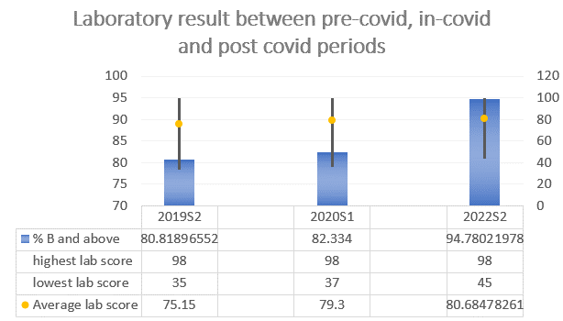

Figure 8: Lab result comparison between pre-covid, peri-covid and post-covid periods

**Conclusions**

In conclusion, the use of virtual labs, such as Matterport, in engineering education has the potential to be an effective way to enhance student learning and engagement, especially during the challenging times of the COVID-19 pandemic. Virtual labs provide students with remote access to real-world engineering project sites, allowing them to explore and analyze designs and structures in ways that were not possible through traditional methods. The virtual lab created using Matterport technology has shown promising results in helping engineering students to complete the perfect gas experiment and gain a deeper understanding of the experimental process and underlying scientific principles. The results of the student survey indicated that the virtual lab was well-received by students, with positive feedback on its effectiveness in teaching engineering concepts. The ability to access the virtual lab remotely and at any time, the annotation feature for taking notes and observations, the embedded instructional videos, and the simulation results have contributed to a more engaging and immersive learning experience. Furthermore, the comparison of laboratory results across different periods, which are pre-, peri-, and post-corona, suggests that the virtual lab can serve as a viable alternative to traditional laboratory work, especially in times when physical access to labs may be limited.

However, it is important to note that virtual labs should not be seen as a complete replacement for traditional laboratory experiences, as hands-on learning and practical skills are still essential in engineering education. Virtual labs should be used as complementary tools to enhance student learning and provide additional opportunities for exploration and analysis. Moreover, further improvements can be made to the virtual lab environment based on the feedback from students and instructors, such as incorporating more interactive features, expanding the range of experiments, and optimizing the user interface for better usability. Thus, virtual labs, such as Matterport, offer a valuable solution to the challenges faced by engineering education during the COVID-19 pandemic and beyond. They provide students with remote access to real-world engineering projects, promote engagement, and enhance understanding of engineering concepts. As technology advances, virtual labs can revolutionize engineering education by providing innovative and immersive learning experiences that complement traditional laboratory work.

**References**

Baher, J. (1998, November). How articulate virtual labs can help in thermodynamics education: a multiple case study. In FIE'98. 28th Annual Frontiers in Education Conference. Moving from 'Teacher-Centred' to 'Learner-Centred' Education. Conference Proceedings (Cat. No. 98CH36214) (Vol. 2, pp. 663-668). IEEE.

Bell, J. & Fogler, S. (2004) “The application of virtual reality to (chemical engineering) education.” 01, pp. 217–218.

Chu, K. C. (1999). What are the benefits of a Virtual Laboratory for student learning? HERDSA Annual International Conference (pp. 1-9), Melbourne, Australia.

Freina, L., & Ott, M. (2015, April). A literature review on immersive virtual reality in education: state of the art and perspectives. In The international scientific conference eLearning and software for education (Vol. 1, No. 133, pp. 10-1007).

Jeschke, S., Thomsen, C., Richter, T., & Scheel, H. (2007, March). On remote and virtual experiments in eLearning in statistical mechanics and thermodynamics. In Fifth Annual IEEE International Conference on Pervasive Computing and Communications Workshops (PerComW'07) (pp. 153-158). IEEE.

Rauch, E., Gualtieri, L., Mark, B. G., De Marchi, M., & Matt, D. T. Digitalization of Practical Laboratory Teaching in Learning Factories in the Age of Covid-19. European Professors of Industrial Engineering and Management, 36.

Robertson, G. G., Card, S. K., & Mackinlay, J. (1993). Three views of virtual reality: Non immersive virtual reality. Computer, 26(2), 81.

Shady, S. F. (2021). Approaches to Teaching a Biomaterials Laboratory Course Online. Journal of Online Engineering Education, 12(1), 01-05.

Wolf, M., Hörnlein, S., Wehking, F., & Söbke, H. (2021, October). Exploratory Study of a 360-degree Model in Environmental Engineering Education. In European Conference on e-Learning (pp. 546-XIX). Academic Conferences International Limited