**Early Science and Engineering Education by Regional Cooperation  
 with Traditional Craft in Fukui KOSEN**

Hitoshi NISHI*,a, Takahiro KOMATSUa and Yukio YAMAMOTOb

a National Institute of Technology, Fukui College (Fukui KOSEN)/  
Department of Electronics and Information Engineering, Fukui Pref., Japan

b National Institute of Technology, Fukui College (Fukui KOSEN)/  
Department of Electrical and Electronic Engineering, Fukui Pref., Japan

*nishi@fukui-nct.ac.jp

**Abstract**

**Fostering next-generation scientists program has been run by National Institute of Technology, Fukui College (Fukui KOSEN) since 2022. The program aims to develop the skills of young people with exceptional aptitude and interest in mathematics and science and to create future leaders in the science and technology fields. The Japan Science and Technology Agency, JST, is a sponsor of the "Fukui KOSEN type PBL for collaboration between traditional industries and digitalized generations" initiative.**

**PBL, or problem-based learning, is used in Fukui KOSEN to help students develop their power of execution and drive for their coursework. They watch businesses in the area around the school and analyze business issues as they study. After that, they present their ideas after deliberating on solutions in groups.**

**This program involves similar process for about 40 elementary and junior high school students to cultivate capacity for problem-solving and innovation for 2 years. In the first year, students of the program join workshops in traditional craft centers near Fukui KOSEN such as Echizen Japanese paper and Echizen traditional chest, and understand histories, techniques and present problems. Students also learn general and special subjects including ICT and IoT provided by Fukui KOSEN. Through the activities and some presentations about their interests, they decide the theme of sequential study.**

**Then 10 students who can take the second year are shortlisted among 40 students in the first year. Each student is assigned to Fukui KOSEN laboratory working on related to their own theme, and studies supported by teachers and tutors. Finally, students who have completed the course can receive certificate of “Junior Doctor”.**

**So far, we had to change some workshops and lectures to remote operation due to COVID-19. However, we have found the validity of this program because participants made great presentation valued by external assessment committees.**

**In this paper, we describe the program detail even in COVID-19 situation.**

**Keywords:** *Early education, PBL, Traditional craft, Regional cooperation, IoT, ICT*

**Introduction**

There are worries about a workforce shortage in several industries in Japan, where the birth rate has been decreasing recently. This is particularly apparent in regional cities, where the dropping birth rate is quickening and many local industries are starting to suffer from a severe labor shortage. Numerous traditional industries, including Echizen Washi, or Japanese handmade paper, Echizen lacquerware, Echizen pottery, Echizen traditional chests, and Echizen cutlery, are concentrated in the Tannan-area of Fukui Prefecture, where the National Institute of Technology, Fukui College (Fukui KOSEN) is situated. Additionally, the production of eyeglass frames and the textile sector have grown to be emblematic of contemporary Fukui Prefecture. There is a severe lack of successors in these established industries as well.

Increasing labor productivity is one approach to this issue. In order to do this, digital transformation is being addressed in a number of industrial areas. Additionally, the development of innovative human resources is essential for future regional revival because they can produce new value.

Japan Science and Technology Agency (JST) is conducting the Fostering Next-Generation Scientists Program, also known as "Junior Doctor Training School" in Japanese, with the goal of developing outstanding human resources. The program seeks to identify elementary and junior high school students with high motivation and outstanding abilities and to certify and support projects that support systematic development plans to further develop their abilities.

On the other side, community engagement with KOSENs is stressed. According to Kaneshige et al. (2007), local KOSEN has demonstrated cooperative efforts. In the creative subjects assigned to each of the main and major courses, Fukui KOSEN is creating Problem Based Learning (PBL) type lessons. Students participate in workshops and company visits connected to these traditional industries in the class. They also propose solutions to issues raised during the course while hearing the viewpoints of businesses and create prototypes. We have discovered that these classes are successful since student-generated ideas have excelled in KOSEN design competitions. According to Furukawa et al. (2016), a university collaborates with a major corporation to carry out PBL. In the instance of Fukui KOSEN, it is distinguished by collaboration with small companies in education.

Fukui KOSEN has therefore been establishing Junior Doctor Training School under the name "Fukui KOSEN type PBL for collaboration between traditional industries and digitalized generations" since 2021. The project is aimed at digital native elementary and junior high school pupils. Our PBL activities give students a taste of traditional industries by applying our expertise in technological teaching. Additionally, it aspires to produce human resources that can contribute actively and creatively to the neighborhood and generate new value.

In this paper, we describe contents of the activities and valid the effects.

**Planning of Collaboration**

To collaborate traditional crafts around Fukui KOSEN, we had searched alliance partner. Then, we found a workshop event in traditional craft studios for sustainable community by an organization called “RENEW.” Fortunately, the undergraduate student in Fukui KOSEN was helping with this RENEW event, and we were able to meet with the chairman of the RENEW. Since 2015, RENEW has been holding events such as studio tours, hands-on workshops, craftsperson symposium, focusing on traditional crafts every year. Nearly 100 workshops and companies exhibited, and a total of more than 30,000 people, including those from inside and outside the prefecture, visited to events. We consulted whether it would be possible to conduct an attractive studio experience-type workshop that has been held at RENEW event in the Junior Doctor Training School. We received a reply that RENEW would like to be involved in the "education" part, and we were able to obtain cooperation with many traditional craft studios for the project through RENEW.

**Contents of the Course**

The institute of Junior Doctor Training School must prepare fostering program in 2 divided stages. We have planned that students take classes in Fukui KOSEN and have workshops in traditional craft studios as the first stage. We also planned that each student is assigned to Fukui KOSEN laboratory working on related to their own theme, and studies supported by teachers and tutors as second stage.

The program in first stage is shown in Table 1. The number of classes is greater than other institutions conducting Junior Doctor Training School. Many classes are reconfigured for elementary and junior high school students with reflection of experience and knowledge of previous extension lectures.

The requirements for completing the first stage are to take all compulsory courses and 7 elective courses out of the 30 courses mainly implemented by Fukui KOSEN.   
  
After elective courses, students must submit report. At the same time, students must join at least 2 traditional craft workshops and 2 presentations at the middle and the final. If student achieve the requirements, they can receive the certificate “Junior Master of Fukui KOSEN.”

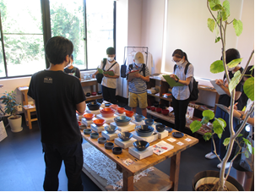

Fig. 1 Workshop in Echizen lacquerware studio

We have given students guidance on the presentation theme which means research title in the second stage. The guidance policy is merger the knowledge from the coursed in Fukui KOSEN and interest in the workshops.

Students who achieve excellent grades in the first stage can proceed to the second stage in the next year. In the stage, students are assigned to laboratories of Fukui KOSEN according to the research theme of each student. They come to Fukui KOSEN on weekend and after school to carry out their research, and are supported by teachers and student tutors.

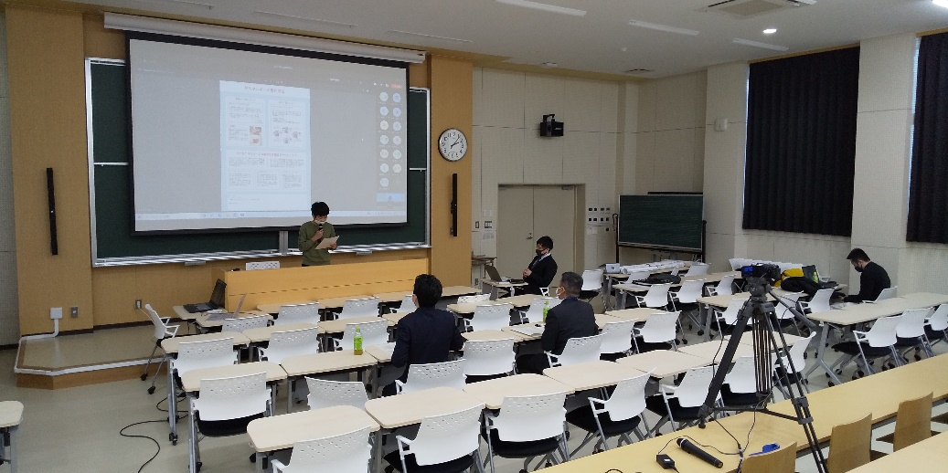

Fig. 2 Final presentation in first stage

**Progress and Validation**

In first year, 2021, we have held only first stage. After document screening of 68 applicants, 4firstudents were accepted. Figure 1 shows the situation of the workshop in Echizen lacquerware studio. Many students had taken a note and ask their questions religiously.

Table 2 shows a part of the title of the middle presentation held face-to-face in Dec. 4th, 2021. Many titles are vague in this stage yet. After the middle presentation, the course related to thinking method was held as one of the compulsory courses. Table 2 also shows a part of the title of the last presentation in March 2first, 2021. The final presentation had been conducted with remote conference system by considering the COVID-19 infection despite the plan of face-to-face with posters in our school gym. So, students who can prepare prototypes and handmade poster might have regretted. Figure 2 shows the situation of final presentation.

Finally, 39 students out of 41 could receive the certificate “Junior Master of Fukui KOSEN,” and 29 students except 9th grade students who cannot be a subject wanted to advance the second stage in next year.

In second year, 2022, we have held first stage for new 4firstudent and second stage for 10 students shortlisted among 4firstudents in the first stage.

The 10 lines from the top of Table 2 shows all themes of the final presentations by the students in the second stage. The theme proposed by the students in the last of the first stage was the basic theme, but the final theme also took into consideration the specialties of the teachers. At the time of the presentation, prototypes and system productions were carried out for all themes, and it was observed that the high motivation of the students continued and the growth of their abilities was seen. In particular, two researches, “Collaboration with Washi industry using pH-responsive pigment extracted from Trifolium pratense” and “Disseminating Information on Traditional Crafts Considering Individual Preferences”, received awards for excellent study at the "Science Conference," an event attended by representatives of Junior Doctor Training Schools nationwide. Both themes were the fusion of young points of view unique to students and the specialized knowledge and skills of Fukui KOSEN, and research content unique to this project. We find that this result shows the high effectiveness of this project.

**Conclusions**

We think that we were able to develop problem-solving skills linked to traditional industries in elementary and junior high school students by implementing Junior Doctor Training School that applied Fukui KOSEN PBL.

Continued activities are required in the future because this project can receive support for 5 years from JST. However, the number of applicants for the second year decreased from the first year to 41, and all of them passed the selection process and proceeded to the first stage. Among them, only 1firstudents wished to proceed to the second stage, which was also less than in the first year. In order to secure highly motivated students, it is necessary to consider not only securing the number of applicants but also improving the training program to make it more attractive.

Students in Fukui KOSEN are participating in this project as tutors. It is thought that teaching elementary and junior high school students will lead to their own growth.

**Acknowledgements**

We would like to express my gratitude to teachers and technical staff who are in charge of the lectures at Fukui KOSEN Junior Doctor Training School. Especially, Mr. T. Kondo, Mr. K. Nishikawa, and Mr. K. Maeda have been involved in the launch and operation of this project. We also say thanks to the cooperation of many staff because this project has been able to proceed smoothly.

**References**

Furukawa Y. et al. (2016). Practical Education through PBL Courses in Collaboration with Industries and Local Communities, J. of JSEE, 64-3, 35-40

Kaneshige A. et al. (2007). A Proposal on How to Make Educational Activities Deep-rooted in the Local Community Successful, J of JSEE, 55-6, 105-110