**Case Studies of Laboratories Using the Concept of "Remote Island Engineering"**

**to Motivate Students to Research and Solve Local Problems**

Kotaro Mori *, a, Takeshi Ito a and Kazushi Kaneto b

a National Institute of Technology (KOSEN), Yuge College, Ehime, Japan

b SORA TO UMI Co., Ltd., Ehime, Japan

*E-Mail: k_mori@yuge.ac.jp

**Abstract**

**Kamijima Town, where the National Institute of Technology, Yuge College (NITYC) is located, is a municipality consisting of remote islands in the Seto Inland Sea. We propose the concept of "remote island engineering”. This concept is to solve island problems through an engineering approach, making full use of the island's resources and human resources, as well as the technical capabilities of the NITYC. At the NITYC, this concept of "remote island engineering" has been spreading from faculty to students over the past few years. Our laboratory involves 5th-year students, sometimes with lower-level students and residents, in helping to solve regional issues as part of their graduation research.**

**For example, there are many abandoned bamboo forests in Kamijima Town, which are not well managed due to the aging of the population. Therefore, our laboratory proposed the "cascading of bamboo” and came up with a method of using it in stages. As the primary use, bamboo houses designed by students are built, and as the secondary use, bamboo charcoal is made from the bamboo used in the bamboo houses. They also experimented to use bamboo charcoal as a fishing reef by sinking it in the sea. Furthermore, remote islands are likely to be isolated in the event of a disaster due to the disruption of lifelines. For this reason, the company is actively involved in disaster prevention and mitigation themes. One such theme is the "development of portable power generation equipment”. This is a combination of a rocket stove, which attracted attention after the Great East Japan Earthquake, and a Stirling engine, an external combustion engine, mounted on a cart so that it can be carried by human power. The students were responsible for all the design and manufacturing for this development.**

**This paper shows that laboratory management based on "remote island engineering" produces the educational outcomes of "independent spirit" and "cooperation with others" when students work on their initiative and take responsibility for their research. Students can experience the practice of the "PDCA cycle," in which they identify issues, set goals, gain new knowledge through experiments and observations, and present their findings at regular meetings to confirm the direction of the project. By having the students experience this cycle for one year, they were able to spend more time in the laboratory and conduct high-quality graduation research.**

**Keywords:** *Remote Island Engineering, Regional Revitalization, Resource Circulation, Self-motivated Learning, Graduation Research*

**Introduction**

"Remote Island KOSEN" The most important aspect to consider when contemplating their significance is differentiation from other educational institutions. Since the introduction of the Model Core Curriculum (MCC) in 2018, the desired content for teaching by each faculty member and the content that students wish to learn have been organized (1). As a result, the National Institute of Technology (KOSEN) has taken on a stronger role as higher education institution where a certain level of education can be obtained regardless of the school chosen. On the other hand, many KOSEN have been struggling with a decrease in the number of applicants due to the significant impact of a declining birth rate in recent years. Therefore, each KOSEN is making efforts to utilize the unique characteristics of their campuses and focus on initiatives to secure a sufficient number of students. The recent establishment of "Kamiyama Marugoto College of Design, Engineering, and Entrepreneurship" is still fresh in memory. This KOSEN has made a good start with an applicant ratio of 9.1 times, fully focusing on the distinctive axis of "fostering start-up human resources and regional development.” The logic that people won't come just because it is located in a rural area no longer holds true. Instead, it is believed that nurturing talents who can explore the strengths of rural areas and work towards solving regional issues is the next step for the KOSEN scattered across 55 locations nationwide, paving the way for the next generation.

The author's affiliation, NITYC, is one of the regional KOSEN and is located on a remote island in the central part of the Seto Inland Sea. While there are nearly 250 inhabited islands in Japan, apart from Okinawa, there are very few remote islands that have higher education institutions such as universities or KOSEN (2). Therefore, they can be considered precious establishments. Considering this situation, NITYC advocates for the promotion of practical education that utilizes the characteristics of remote islands, which is referred to as "Remote Island Engineering." It involves addressing the island's challenges by leveraging the island's resources, talents, and the technical expertise of the KOSEN to solve them through an engineering approach. The objectives of this education are to contribute to the local community and cultivate talents who can lead new industries. It is important for students to have confidence that they have solved local issues by utilizing the knowledge and skills they learned at KOSEN (3).

The authors' laboratory conducts graduation research on the theme of "Remote Island Engineering”. Every year, fifth-year students choose their research laboratory, and the faculty members of each laboratory either assign research topics to the students or allow them to specify their own topics. The research is carried out over approximately one year. In the Department of Electronic and Mechanical Engineering at NITYC, the approach to graduation research is left to the discretion of the supervising faculty members. While the faculty members aim to produce high-quality graduation theses, it is not uncommon for the progress of research to be hindered by the characteristics and motivation of assigned students, which can create a significant burden on the supervising faculty members. In the past, this laboratory has been searching for ways to convey the appeal of research to such unenthusiastic students and encourage them to independently discover issues, consider methods, and take approaches. Recently, by making the theme of our laboratory consistently related to "Remote Island Engineering," we have been able to attract students who are interested in contributing to the local community and the natural environment of remote islands. As a result, in the graduation research projects conducted in the past two years, we have seen the ideas and intentions of the supervising faculty members permeate the research, leading to achievements such as winning awards in academic presentations.

This paper introduces two examples of graduation research projects: "Development of Portable Power Generation Equipment for Disaster Prevention and Mitigation" and "Improvement of Marine Environment through Cascading of Bamboo." Both topics were chosen by the students themselves, who were responsible for designing and conducting experiments and persevering through failures until completing their research papers. Of course, there are times when students' motivation wanes along the way. However, even in such situations, the teachers did not present methods, but only gave hints, and instilled the mindset that "research is not something imposed on them but something they must take on themselves." By adopting this approach, the students are encouraged to take ownership of their research and understand that it is their responsibility to tackle the challenges. The teachers provide guidance and support as needed, but the emphasis is on fostering a sense of autonomy and self-motivation.

Here are the guidelines of our laboratory:

1. During the initial meeting, we conduct a brainstorming session with all members to generate multiple problem statements and approaches based on "Remote Island Engineering."
2. Through the first semester, we encourage each team to work on two or three research themes simultaneously rather than narrowing them down to a single topic. Additionally, if another team requires assistance with their project and manpower, teams collaborate and support each other.
3. Every two weeks, we hold progress report meetings. Each team presents their findings for approximately 10 minutes using PowerPoint slides, and all members attend to provide feedback and engage in discussions.

**1st Case Study: Development of** **Portable Power Generation Equipment for Disaster Prevention and Mitigation**

In response to the challenge of "ensuring infrastructure during disasters" faced by remote islands like Kamijima Town, which heavily relies on mainland supplies for essential resources like water and electricity, students conducted a graduation research project on the development of a portable power generation system that combines a rocket stove, which can be easily produced even in disaster-affected areas and used for cooking food and heating, with an external combustion engine known as a Stirling engine. The research group consisted of three members, with roles divided into leader, designer, and electrical engineer.

The research project utilized an ADMIEXCO company's 90-degree V-gamma type water-cooled single-unit Stirling engine, as shown in Figure 1. The rocket stove was newly made to be adapted to this engine and with an insulated structure and durable design. Additionally, the dedicated framework was designed so that all other power generation units and cooling water tanks could be mounted on the cart, and a 3D model was created as shown in Figure 2. The CAD software used for this purpose was Autodesk Fusion 360, obtained through an educational institution's free license.

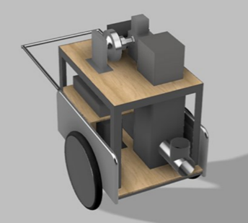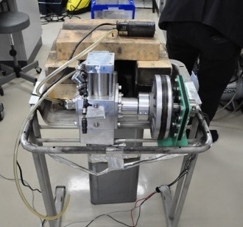

Figure 1. Appearance of ADMIEXCO company's Stirling engine

Figure 2. 3D model of the portable power generation equipment

The first step, they took was to investigate the mechanism and structure of the Stirling engine. Although the students had learned about the Carnot cycle in their fourth-year thermodynamics class and were familiar with the operating principles of the Stirling engine, it was their first time interacting with a real engine. Therefore, they conducted research on literature related to the Stirling engine. Additionally, they performed multiple operating tests on the ADMIEXCO company’s Stirling engine, which was planned to be installed, to determine the operating temperatures and amount of firewood needed.

A distinctive feature of this group was that, on completing the experiments, the students voluntarily engaged in brainstorming sessions to discuss and consolidate the identified issues, along with their corresponding solutions and insights. This process occurred without direct instruction from the teachers, as the students took the initiative to carry it out.

In the next step, they proceeded with the making of the rocket stove. A rocket stove is a combustion device that consists of an insulated exhaust pipe (heat riser) and a combustion chamber (burn tunnel), which uses wood or similar materials as fuel. When the fuel placed in the burn tunnel ignites, wood gas is generated, and this combustible gas undergoes secondary combustion within the heat riser. As a result, a chimney effect is created, leading to a strong updraft inside the heat riser. The updraft creates a negative pressure in the burn tunnel, causing outside air to be drawn into the burn tunnel through the fuel inlet. This enhances combustion efficiency, resulting in exhaust gases approaching near-complete combustion. Professor Ito, who is one of the co-authors of this paper, had previously conducted research on rocket stoves and possessed a simplified version using an 18-liter square can. However, the students decided to design and make a new rocket stove for this project.

The concept for the rocket stove is as follows:

1. Design and make the stove from scratch.
2. Ensure it has the strength to withstand long hours of operation.
3. Extend the length of the heat riser section compared to existing models to improve efficiency.
4. Implement thorough insulation to enhance efficiency.

Following the above concept, the students went through a series of trial-and-error iterations, and the new rocket stove was completed. Figures 3 to 5 show the sequential steps of the process and the final product of the rocket stove. A comparison of the combustion temperature was conducted between the new rocket stove and the existing rocket stove, as shown in Figure 6. It demonstrates that the new rocket stove achieved stable combustion at approximately 700 degree-C for about 10 minutes, surpassing the existing model by providing stable combustion at higher temperatures.

Furthermore, the team proceeded with the making of the framework, making of an insulation container to efficiently transfer the heat from the rocket stove to the Stirling engine heating unit, assembly on the cart, and installation of electrical components. As a result, "Portable Power Generation Equipment" as shown in Figure 7 was completed. The students presented this achievement at the "Hyper Interdisciplinary Conference in Tokyo 2022" and received the "Monozukuri Research Center Award" from the organizing company, Leave a Nest Co., Ltd.

It is rare for the year-long efforts of a graduation research project to culminate in an award at a conference. However, even without the award, these students were highly satisfied with their research outcomes. They continued conducting operational experiments with the completed device until just before the paper presentation. Unfortunately, they were unable to acquire data on power generation for that year, but this task was passed on to the following year. The student who led the development team later remarked, "The experience of building something from scratch in this laboratory was incredibly valuable."

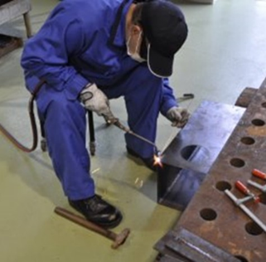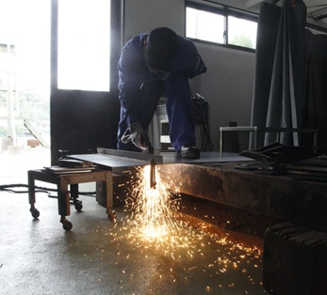

Figure 3. Cutting the steel plates

Figure 4. Welding the steel plates

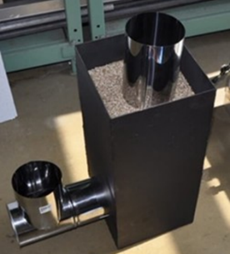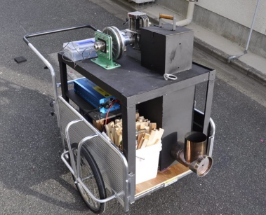

Figure 5. The final product of the rocket stove

Figure 7. Appearance of “Portable Power Generation Equipment"

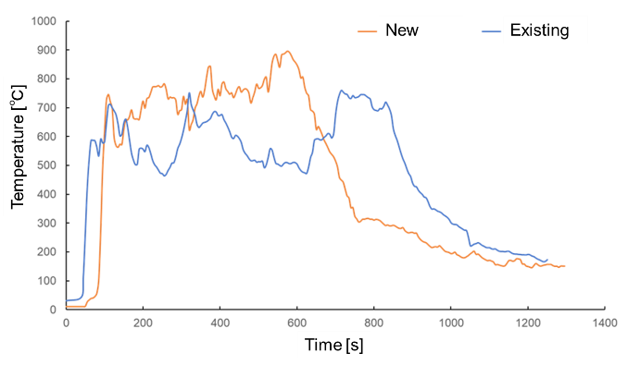

Figure 6. The comparison of the combustion temperature between the new and the existing rocket stove

**2nd Case Study: Improvement of Marine Environment through Cascading of Bamboo**

In the author’s laboratory, we advocate for the concept of "Cascading of Bamboo" as a method to give added value to the increasing amount of abandoned bamboo on the island and actively promote its harvesting and management. Cascading involves multiple stages of recycling, starting from high-quality recycling and gradually transitioning to lower-quality recycling, with the aim of utilizing biomass resources effectively (4). Over the years, all members of the laboratory have been actively involved in harvesting bamboo from abandoned bamboo forests near the school and exploring various ways to utilize it.

For example, among the harvested bamboo, the ones in good condition were used as materials to construct a bamboo house. This was a project proposed by one of the members involved in the "Cascading of Bamboo" initiative, and this student took the lead in designing and assembling the house. Figures 8 and 9 show the actual bamboo house that was built.

In addition, bamboo charcoal was produced from the harvested bamboo, including the primary used for the bamboo house construction. Bamboo charcoal serves as a biomass fuel and is also utilized as a deodorizer and moisture absorber due to its fine pores on the surface. The potential of these fine pores in bamboo charcoal to improve marine environments was investigated in the graduation research project. Such marine-related topics are highly relevant and accessible for NITYC, a KOSEN located on an island. The students enthusiastically conducted fieldwork and made an interesting discovery when they retrieved the bamboo charcoal submerged in the sea at the pontoon. Therefore, they found that numerous microorganisms had attached to it. The results of this experiment indicate that submerging bamboo charcoal in the sea can be expected to be effective as a fish reef where microorganisms attach and eventually attract small fish that prey on the microorganisms. This achievement was presented by the students at the "Hyper Interdisciplinary Conference in Osaka 2022" as shown in Figure 10.

Furthermore, inspired by the research achievements of their seniors, the current members of the graduation research team have engaged in discussions and are tackling the creation of fish reefs using bamboo and bamboo charcoal. It is evident that the new members have been influenced by the research accomplishments of their seniors.

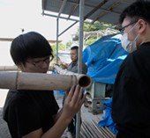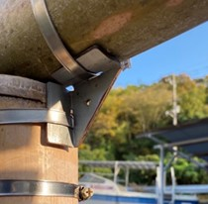

Figure 8. Assembling the bamboo house

Figure 9. Joint part between bamboos

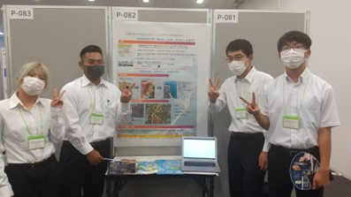

Figure 10. Poster presentations at conferences

**Conclusions**

As mentioned above, the author's laboratory has incorporated the theme of "Remote Island Engineering" in graduation research, enabling students to identify their challenges, devise approaches, actively learn, and publicly present their findings. The students formulate research plans, put them into action, sometimes face failures, and present their progress at progress report meetings to receive feedback from teachers and colleagues. Through this iterative process, a "PDCA cycle" naturally takes shape, empowering students to autonomously advance their research toward problem-solving.

Even more, collaboration with the local community is essential in solving local problems. In the author's laboratory, it has become a gathering place for various activities involving residents, including Mr. Kaneto, a co-author who actively participates as an islander, and students from nearby Yuge High School. It is important to create a laboratory that is accessible to both students and residents, where everyone feels welcome to participate.

**Acknowledgements**

The project of “Development of Portable Power Generation Equipment for Disaster Prevention and Mitigation” was supported by a shared subsidy from Grant-in-Aid for Scientific Research.

**References**

1. S. Tadano (2019). Kosen Education to Lead Future Learning：2. Quality Assurance for Engineering Education in National Institute of Technology (KOSEN), *IPSJ Magazine*, 60 (7), 596-599
2. M. Higashi (2010). Problems in Small Islands and Prospects for Kagoshima University, *OCCASIONAL PAPERS*, 50, 33-36
3. K. Ise (2019). Isolated Island Engineering Helps Students Develop, *J. of JSEE*, 67 (4), 33-34
4. K. Mimura, K. Okada, R. Miyazaki, K Yamada (2017). The biomass cascade model in Yume-Take Valley for using Bamboo, *Proceedings of the Conference on Biomass Science*, 12 (0), 41-42