ONLINE TEAROOM DESIGN INTERNATIONAL WORKSHOP:
NEW CHALLENGES

A.P. HIGASHINO^{*,a}, K. KUDOHª

ª National Institute of technology /Architecture Department, Akashi College, Akashi, Japan

*adriana@akashi.ac.jp

Abstract

Akashi College Architecture Department offered online international design workshops to replace the international exchange activities suspended due to the COVID-19 pandemic.
The first online design workshop started in November 2020 and ended in January 2021. It had 53 participants, including students from Japan, Brazil, Hong Kong, Indonesia, and Singapore. The second online design workshop started in October 2021 and ended in January 2022. It had 90 participants: 84 students from Japan, Brazil, Hong Kong, Germany, the Philippines, and Mexico, and 6 Taiwanese teachers from six different Kaohsiung municipal technical high schools. The third workshop started in November 2022 and ended in February 2023. It had 50 participants, including students from Japan, Brazil, Hong Kong, and Germany. All workshops had once a week an online meeting session of 90 minutes. The students worked in groups and developed a design for a tearoom. At the end of the workshop, they explained their design using drawings and a five-minute video presentation. These workshops were part of an elective course for Japanese students, and they worked together in the same room while having online meetings with their international group members. Two instructors monitored the online sessions and assisted the students when necessary.
This paper offers practical teaching suggestions by comparing the results from three workshops. The action research methodology was used to evaluate the workshops, diagnose the problems, and implement solutions. The diagnosis was made through interviews and observation of the students during the workshop and post-workshop surveys. Also, the product of the workshops, the tearoom designs developed by the students, are analyzed and compared. First, we explain how the workshops, from the recruitment of the students to the final presentation. We present difficulties and troubles experienced during each workshop. Later, we will compare the products of the workshops and the tearoom designs of the online workshop with the previous offline workshop.

Keywords: online design workshop, international ex-change, tearoom, traditional Japanese architecture
Introduction
Architectural practice is a global profession, and architecture students must be prepared to work in a multicultural environment. In a country such as Japan, with a culturally homogeneous society and few immigrants, internationalizing the educational environment goes beyond improving the student's knowledge of English.
How do we prepare Japanese students to work in a multicultural context through studio teaching?
The idea was simple: organize a design workshop, invite students from abroad, and have them work with our students on an architectural design. We organized a 3-week Japanese architecture internship program with lectures, field trips, workshops, and, as the main event, the tearoom design workshop.
The first tearoom design workshop was in 2015, and the last was in January 2020. During the first design workshops, there were several problems and miscommunication between the students. The design workshops showed that communication between the students also involved understating social rules with a strong cultural background. Japanese students expected the international students to act according to rules that the international students were not familiar with, resulting in angry students from both sides. (Dupre,2018) However, this problem was solved over time. Through interaction with international students, Japanese students learned to accept international students' behavior and communicate with people from different cultural backgrounds. (Higashino,2019)
Unfortunately, due to the COVID-19 pandemic, academic activities that involved traveling abroad or receiving international students had to be canceled. It was impossible to accept international students, so we decided to hold the design workshop online.
The idea of an online design workshop is older than the pandemic. The Japanese architecture internship program had few international participants, mainly because of the costs of coming to Japan. Therefore, if some of the activities were online, more international students could participate, resulting in more exposition of Japanese students in a global context. However, before the pandemic to organize an online workshop was complicated. There was a lack of tools and interest of the students. (Higashino, 2018)
The first online design workshop started in November 2020 and ended in January 2021. The second workshop started in October 2021 and ended in January 2021. The third workshop began in November 2022 and ended in February 2023.

Materials and Methodology

In this research, we used the action research method, which understands teaching as a research method through experience, reflection, and practice. The method consists of reflection based on the diagnosis process of the teaching experience.
The action research method has three steps:
1st is to detect and diagnose the problem.
2^{nd,} elaborate a plan to solve the problem, apply it, and collect the results.
3rd is to analyze the results and feedback that will lead back to the 1st step, and a new diagnosis and process of reflection and action occur. (Elliot,1991)
The workshops were project-based, and the instructors defined the final product, the format, and the design process. The main goal of the workshops is the interaction between the students, and the quality of the final product is secondary.
During the workshops, we collected the material to diagnose and solve problems as quickly as possible. This material consists of interviews with the students and surveys at the end of each workshop. The interviews with the Japanese students happened face to face, while for the international students, the interviews were through Zoom or Facebook chat. We also did a photography record of the students during the workshop and took screenshots of their interactions on Facebook. This material was collected during each of the workshops and helped reflect and diagnose problems. The workshop schedule was kept flexible, and the deadlines were adjusted as necessary.

The Online Tearoom Workshop

The workshop can be divided into 3 phases. The 1st phase consists of gathering international students to participate in the workshop dividing and organizing the students into groups. The 2nd phase is the longest, where the students work together and develop a design for a tearoom. The 3rd phase is the presentation of the final product.
To gather international students to participate in the workshop, we posted on the school website and sent a flyer explaining the workshop activities to our partners' schools. As the survey showed (Fig.1), most of the international students joined the workshop because it was recommended by their teachers. In the first year, 2021, the international participants were students from Brazil (UFRGS), Hong Kong (IVE Tsing Yi), Singapore (Nanyang Polytechnic), and Indonesia (Diponegoro University). In the second year,2022, there were students from Brazil, Hong Kong, the Philippines, Mexico (De La Salle University Integrated School), Taiwan (Kaohsiung Municipal Technical High Schools), and Germany (Augsburg University of Applied Sciences). The international students work together with Akashi College
4th-year architecture students. According to the international students' survey, most of them joined the workshop because they wanted to learn about Japanese Architecture and culture, learn about architectural design, interact with people from other countries, and practice English. In the second year, some students said that friends who participated in the previous year's workshop recommended it.
The workshop was conducted on an SNS platform and used Facebook for exchanging data and Zoom for online meetings. We could not use any LMS platform, such as Google Classroom and Microsoft Teams, because the National Institute of Technology cyber security does not allow us to invite people from outside the institution. First, we created a closed group on Facebook and added all the workshop participants to this group. In all three years of the workshop, some students did not have a Facebook account and had trouble joining the group.
After all the students were in the Facebook group, we divided them into smaller groups. The main group was used for transmitting information about Japanese architecture, with lectures and recommended literacy, and to inform on the workshop schedule changes. The smaller Facebook groups were used for exchanging design ideas and developing the tearoom design. The tutors monitored the Facebook group pages and advised the students when necessary.
In the first online meeting (Zoom), we explained the workshop's goals and how the students should develop and present their designs. Also, during the meeting, each student made a short self-introduction. The session was recorded and later posted on the main Facebook page.
The students had to elaborate the design concept and develop it into the design for the tearoom. They have to explain their design ideas using drawings, CG, and models. They also had to make boards with drawings and a final video presentation explaining the design of their tearoom and post it on the main Facebook group page.
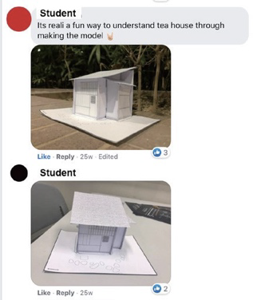
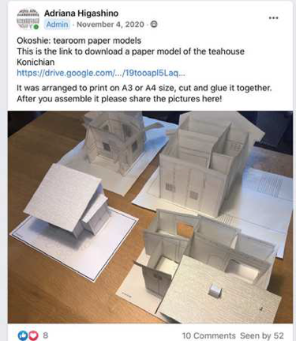
Figure 1: Tearoom paper model assignment and student
Reaction, Facebook group page screenshot.

In addition, the instructors also posted video lectures about Traditional Japanese architecture to help the international students understand a bit of traditional Japanese Architecture. The Japanese students also researched contemporary tearoom examples and posted them on Facebook.
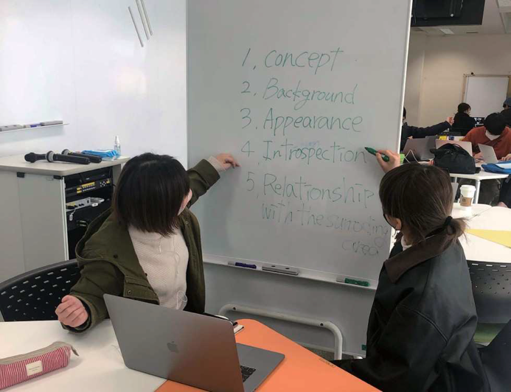
Figure 2: Photo of the students discussing their design concept.

Disconnection and miscommunication were the main troubles during the workshop; overcoming those obstacles was the workshop's primary goal. We explained to them that this was also part of the experience. Some students understood, and others did not. None of the participants were native English speakers, and communication was difficult. However, as one student commented, "It was funny to have some members talking Japanese or Portuguese and translating with drawings."

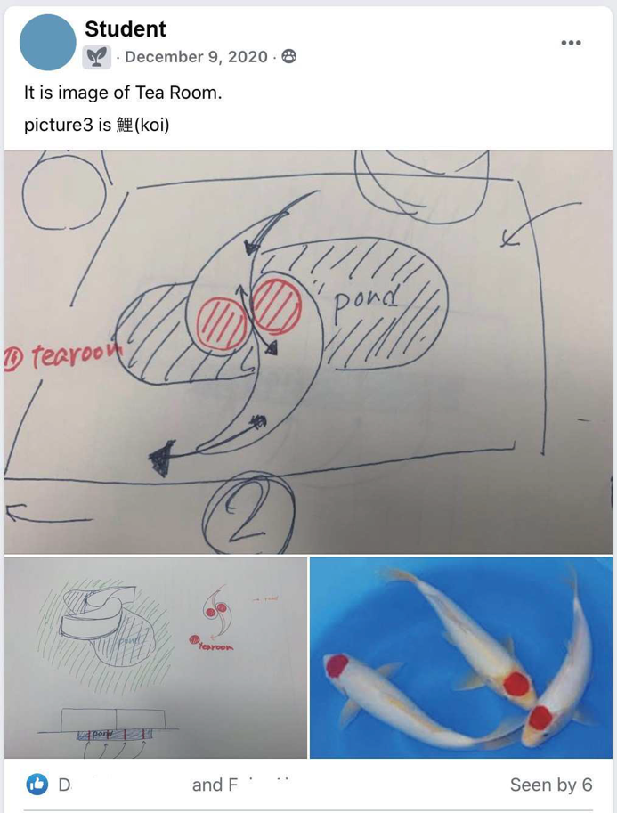

Figure 3: screenshot of a Facebook group page showing how the students interact and share their ideas.

Troubles and Obstacles

Apart from some students' difficult communication and low English level, the biggest obstacle during the workshop was the time difference and Akashi College's bad internet connection. The workshop is part of a 4th-year elective course for the Architecture major, and the online workshop sessions had to happen during the course classes schedule, which was 10:40 am Japan standard time. The time difference was tough on the students from Germany, who had to join the workshop at 3 a.m.
In the first year, the workshop was on a Wednesday, and we had no significant problems with the internet connection. However, the workshop was on a Monday in the second and third years. That is when we realized that Monday is not a good day of the week for online workshops. First, the school internet was down several times, and we had to postpone the meetings. Most of the repair work in the school happens during the weekend. Every time they need to turn off the electricity, the school server goes down, and on Monday morning, it is not back yet. Also, as a student from Brazil pointed "The lessons were good, but Sunday night, it's hard to maintain focus."

Table1: Number of students in the Workshop
year | Application Form | Conclusion Form | concluded workshop
2020 | 30 | 26 | 87%
2021 | 65 | 44 | 67%
2022 | 29 | 16 | 55%

Table 1 compares the number of international students who answered the application form to those who answered the conclusion form. As the table shows, many of the international students did not finish the workshop. The number of international students who gave up in the middle of the workshop increased over the year. In the second year, we even had to rearrange the groups because there were groups with only two members left.
Why did so many students quit?
In the second year, 2021, the tutors taught that so many international students quit because there were too many participants and too many groups for the two tutors to accessorize. While in the first year, the Japanese students worked together in the same room, in the second year, we had to split them into two rooms, which made it difficult for the teachers to help the students. Also, some groups of the 2021 workshop refused to use Facebook to share and develop their ideas, which made it more complicated for the tutors to advise them along the design process.
Based on the 2021 workshop experience, in the next year's workshop, the number of groups was limited to 10. And the students were forced to post their design process ideas on Facebook. Unfortunately, those were not the only reasons international students quit the workshop, and on the 3rd workshop of 2022, half of the international students who applied did not finish.

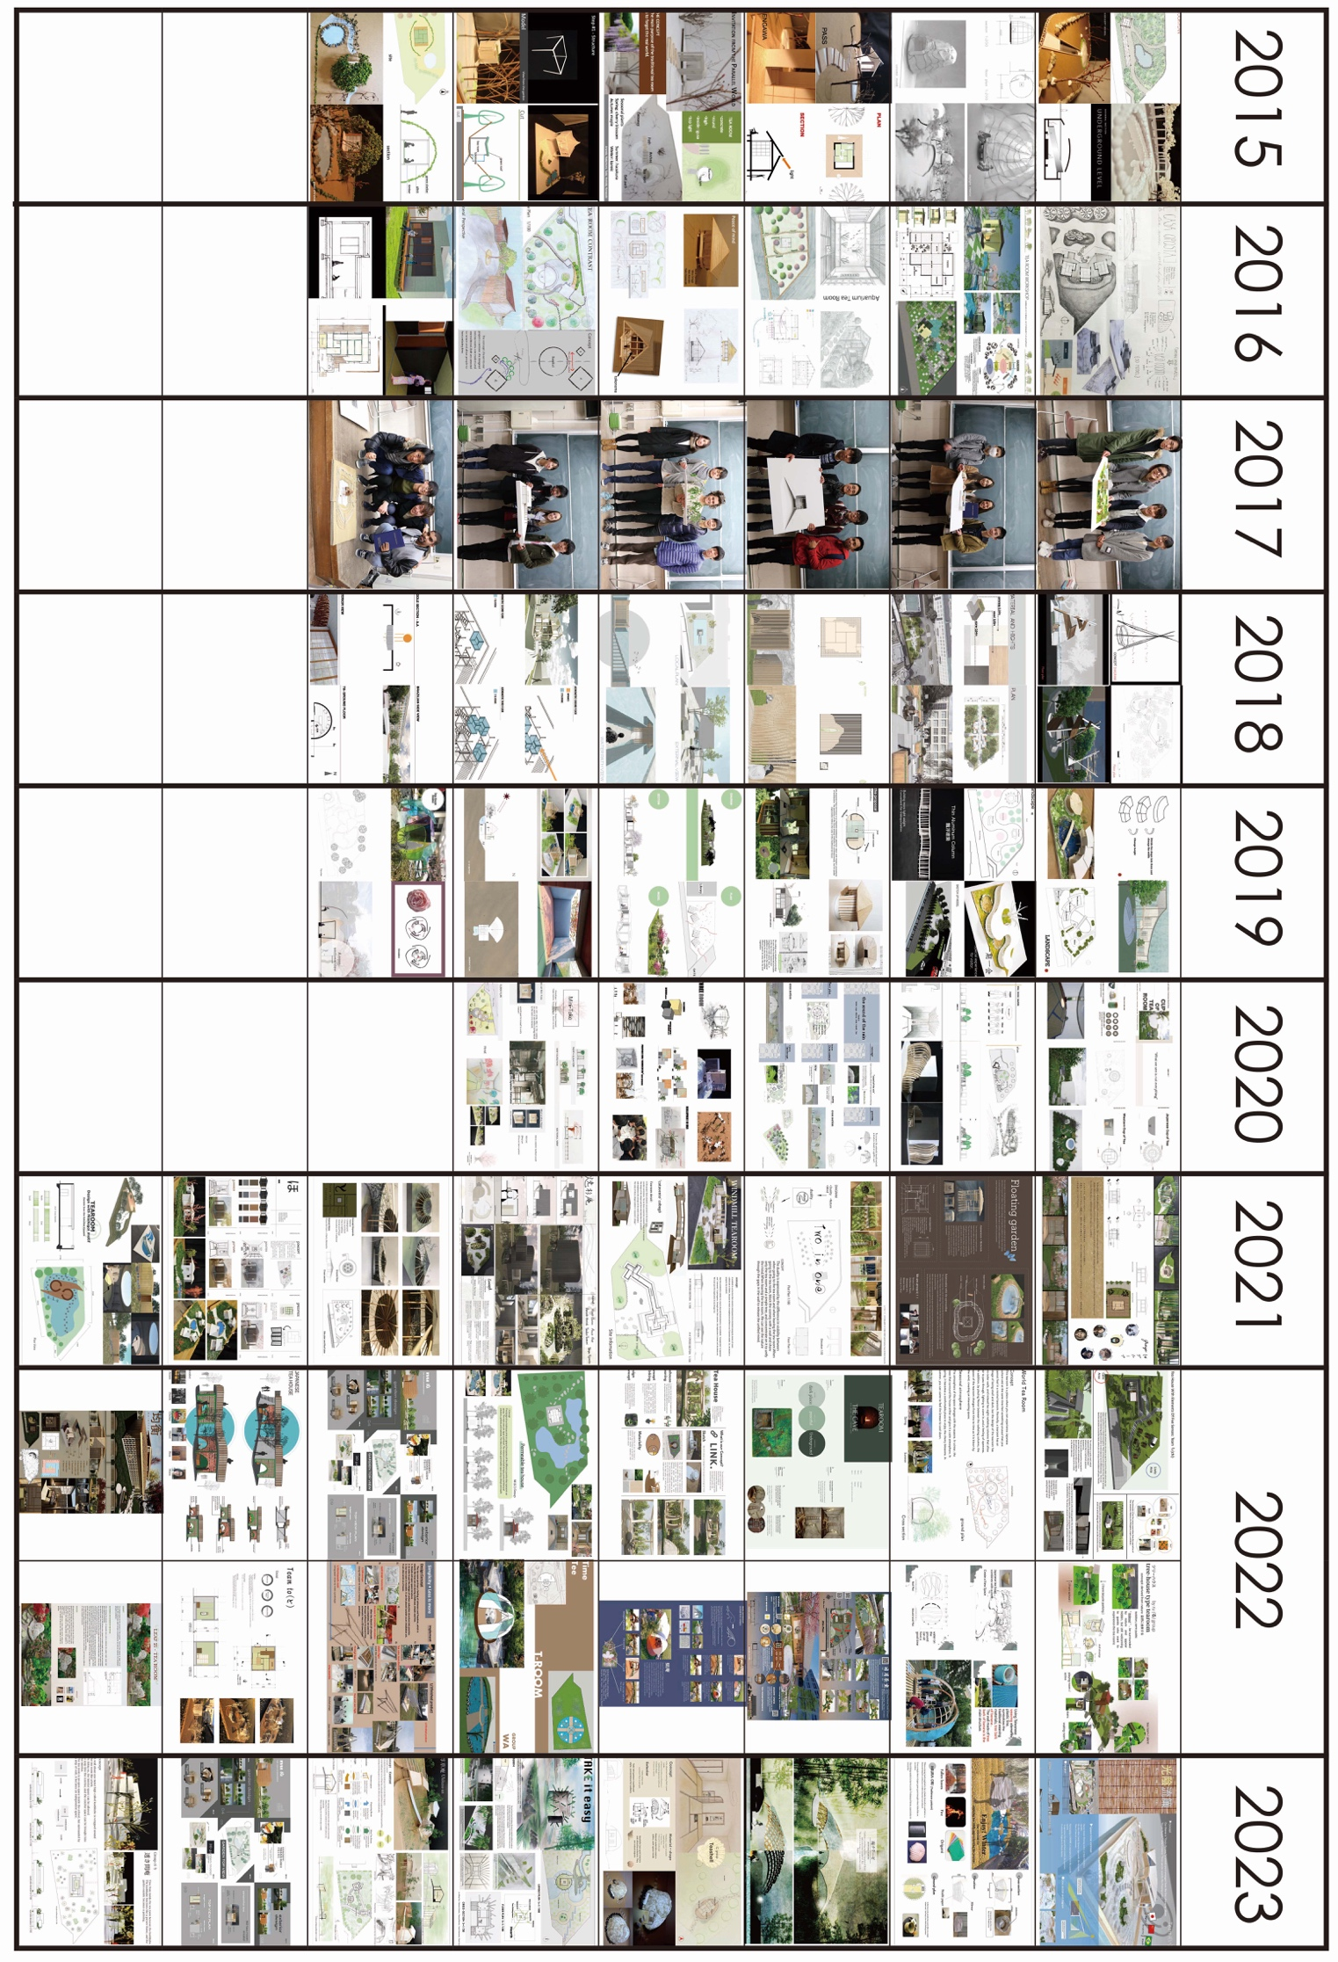
Figure 4: Comparison of the student's works
Through the interview with some of these international students, we learned that there were basically 2 reasons for them to quit. The main reason was that the pandemic was over, and the offline classes restarted. Some students from Brazil said they were too busy with university and could not continue participating in the workshop. Some international students complained about our school internet's bad connection, and the sudden cancellation of the workshop sessions was also a reason for them to quit. For students from Brazil and Germany who had to stay awake until late at night to participate in the workshop, it was no fun to have the meeting canceled.

Results and Discussion

After the workshop, the students answered a survey to help us evaluate the workshops. Many of the international students were at the beginning of the Architecture course and did not have much experience with architectural planning or drawing. The feedback from the students was, in general, positive.
When asked if the workshop was up to their expectations, most of the students answered that they were satisfied with the workshop, and there was no student unsatisfied with the workshop.
Regarding communication tools, in 2020, some students were not familiar with Facebook and ZOOM, but thanks to the pandemic and online classes, by 2022, all students were used to the online tools. In addition to Facebook and ZOOM, the students also used other SNS platforms to communicate, such as Line, Instagram, and WhatsApp. As the survey showed, all students met outside the workshop meeting date.
Concerning the division of tasks, all students equally participated in the design process. Most international students executed the computer drawings and 3D computer models, while the Japanese students made the architectural models. Most of the students answered that they were satisfied with the tearoom they designed and what they produced during the workshop. In the first workshop, we allowed the students from Brazil to pair with friends, and we ended up with groups that only had 1st-year students, while in other groups, the students were more advanced in the course and had better architecture presentation skills. Figure 4 shows that on the works of the students from the 2021 workshop, there were groups with students at the end of the Architecture course and amazing drawing and CG skills, while other groups had first-year students drawing for the first time. From 2022, in the 2nd and 3rd workshops, we tried to mix students at different stages of the architecture course, and that resulted in less difference between the student's presentation skills (Fig4. 2022, 2023)
Figure 4 chart compares the students' tearoom, the workshops' product since the first (face-to-face) workshop and the last 3 online workshops. Over the years, we can see fewer hand drawings and more CG drawings made with AutoCAD.
In both types of workshops, offline and online workshop, the students' works showed some common elements:
1)The design of the path to the tearoom, and in this path, a series of events happen.
2)Underground space.
3)The use of a 4 and 1/2 tatami mats floor plan.
4) Various 4 and 1/2 mat floor plans combined.
5) The elaboration of a concept for the tea space.
4) A formal approach and disconnection of the design with the tearoom theme.
The comparison of the students’ works shows the there is no difference between the quality of the product from the two types of workshops. Two students that participate on both types of workshops said that they were surprised that they could work online with international students and that the online workshop was much more interesting them they expected. However, they said that in the offline workshops they could establish a more intimate relation with their group’s members. According to them in the online workshop they had the chance to interact with a bigger number of international students, but in the off-line workshop this interaction was more intense.

Conclusions

The tearoom design workshop was a positive experience for the students in its offline and online editions. All groups developed a design concept and explained their ideas using drawings, CG, and models. Some groups had difficulty communicating, and the instructors had to give them some support. When the design workshop is online, the students need more time to discuss and develop their ideas than a face-to-face workshop. However, the online workshop allowed low-income students to participate in international exchange activities. During the pandemic, online design workshop was very popular, especially among students from Brazil, but as life went back to normal, it became more difficult to gather participants for the workshop.
The instructors were satisfied with the results, and we intend to repeat the online design workshop. The next step is to try to have a hybrid version, where the students start the workshop online and finish face-to-face in Akashi.

Acknowledgments

We want to thank Prof. Renato Fiore (UFRGS University, Brazil), Prof. Keith Chan (IVE, Tsing Yi, Hong Kong), and the teachers from Kaohsiung Municipal Technical High Schools for their help and support in organizing and making the online design workshop possible.

References

Elliott, J. , Action Research for Educational Change. 2019 Open University Press, Buckingham.

K. Dupre, A P Higashino, Australia-Japan Tearoom Design Workshop: Questioning the Validity and Effectiveness of International Partnerships and Summer Schools, 2018, Charrette, Volume 5, Number 1, Spring 2018, pp. 78-89

Adriana Piccinini Higashino, Internationalization of Architect’s Education: Five Years of Tearoom Design
International Workshop at NIT Akashi College, aae2019
: learning through practice: the aae conference 2019
University of Westminster, London 2019
https://aaeconference2019.wordpress.com

National Institute of Technology, (KOSEN), Akashi
College home page 2020 workshop
http://www.akashi.ac.jp/news/2020/o7en060000002yi3.html

National Institute of Technology, (KOSEN), Akashi
College home page 2021workshop
https://www.akashi.ac.jp/news/2021/20220221arc001.html

National Institute of Technology, (KOSEN), Akashi
College home page 2022 workshop
https://www.akashi.ac.jp/news/2022/20230301arc001.html

Students video presentation channel

Videos of 2020 workshop
https://www.youtube.com/playlist?list=PLkMmRzT1WS1YYWocW5hFHwsU-eBgEa-lD

Videos of 2021 workshop
https://www.youtube.com/playlist?list=PLkMmRzT1WS1aq224wjy2Ul5-BSU4ZM_1W

Videos of 2022 workshop
https://www.youtube.com/playlist?list=PLxat57oO1e3PiG44Wzmg9_GWYF-3GWwf-

