**THE SUSTAINABILITY OF VIRTUAL LABORATORIES IN THE POST-COVID-19 ERA: IMPLICATIONS FOR RESILIENCE STRATEGIES TO PROMOTE STUDENTS' LEARNING EFFECTIVENESS**

Nanoka K.M. TSE a,* and, Benson K.H. HUNG b,**

a Department of Information Technology, HK Institute of Vocational Education (Tsing Yi), Vocational Training Council, HKSAR, China

b Workplace Learning and Assessment Project Team (Engineering Programmes), Vocational Training Council, HKSAR, China

* nanokatse@vtc.edu.hk

** bensonhung@vtc.edu.hk

**Abstract**

The COVID-19 pandemic has caused significant disruptions to the traditional delivery of engineering education, as institutions and universities were forced to move to online and hybrid formats to prevent the spread of the virus. During the pandemic, the use of virtual laboratories replaced physical laboratories to a certain extent in supporting the learning process in most institutions. Therefore, laboratory work is one of the certain face-to-face activities that cannot be easily replaced by a virtual approach. In view of the end of COVID-19 in sight, this shift to a virtual approach has presented a question for educators to understand the sustainability of virtual laboratories in the post-COVID-19 era and how virtual laboratories can be effectively integrated into the curriculum for future teaching and learning development. This research used a quantitative data collection method (i.e. a teacher survey; N=22) to evaluate the eight potential sustainability strategies that addressed the three main research questions. According to the research, the views on whether virtual laboratories can generate positive impacts on the quality of education and learning objectives of their courses during the COVID-19 pandemic were diversified. Results showed that the possibility of virtual laboratories opens up new perspectives for higher education sustainability, however engineering teachers preferred maintaining the current use of virtual laboratories rather than optimising this educational approach. Reactive measures instead of proactive measures were considered more attractive for teachers in attaining sustainability of virtual laboratories in the post-covid-19 era. Resilience strategies that focus on maintaining positive outcomes and reducing negative impacts shall be in place to promote students' learning effectiveness.

**Keywords:** *virtual laboratory; science and engineering; higher education; sustainability; resilience.*

**Introduction**

Laboratory experience is a key factor in technical and engineering education and laboratories are important environments for student learning. Practical works are critical to the learning process in science and engineering education. Science and technology education is based on the students’ experimentation in a laboratory, where theoretical models are confirmed, and the teaching is given a practical orientation (Cabedo et al., 2018). They are an important and integral part of hands-on experience for science and engineering students which provide a better understanding of the theoretical concepts learned in classrooms.

In Hong Kong, with the outbreak of COVID-19 in early 2020, most of, if not all, the face-to-face laboratories were suspended and replaced by non-traditional or simulation laboratories. The latest technological advancements provided great opportunities for institutes to go over geographic and time restrictions using 3D virtual learning environments that support simulations and observations of various experiments. However, certain face-to-face activities such as laboratory work cannot be easily replaced by online mode, according to a perception study on microbiology laboratory sessions (Joji et al., 2022). Although the high success rate of virtual laboratories in institutions of education and training was noted (Azad, 2007), there is an increasing concern about the sustainability of these virtual laboratories across the higher education sector. As such, this research aims to answer the following research questions:

* What is the role of virtual laboratories in post-COVID for engineering education?
* How do engineering teachers perceive the future use of virtual laboratories in their teaching after COVID-19?
* How can virtual laboratories be effectively integrated into the curriculum to enhance student learning outcomes?

**Background**

Virtual laboratories have been proposed to students with less popularity before the COVID-19 pandemic. Home laboratory kits were adopted by oversea institutions such that students could conduct real experiments at home (Tan et al., 2019). Students were required to come back to the institution for collection and the number of laboratory kits was great for large class sizes. Therefore, the types of experiments that can be done at home were limited due to complexity and safety concerns.

During the COVID-19 pandemic, the learning and teaching of science and engineering subjects faced a big challenge because all face-to-face laboratory work was suspended. Since laboratory works were essential and critical elements of science and engineering education. Teachers tried other means to relieve the effect by performing a demonstration, simulation or virtual laboratory, such that experimental data can be collected for analysis afterwards. However, students commented that they cannot see and control the laboratory apparatus in “real” time. Hence, a virtual laboratory approach for engineering education was proposed to facilitate student independent learning, enhance their learning experience, and solve the adverse effect created by the suspension of face-to-face laboratory work.

The COVID-19 pandemic has forced face-to-face laboratory work to be suspended. As a result, the demand for alternative delivery modes of the laboratory has increased significantly. In response, various virtual laboratories have been developed across different institutes to address these challenges. Since laboratory work plays a critical role in science and engineering education, teachers were using various methods to let students complete laboratory work at home instead of simply cancelling the laboratory work. While some teachers employed high-quality simulations or virtual laboratories, students who cannot have hands-on experience with real laboratory equipment and materials were criticized.

The Hong Kong Institute of Vocation Education (IVE) considers laboratory works are essential components of the Higher Diploma (HD) engineering programme and normally requires students to perform experiments in person. Apart from learning practical skills, through laboratories, students develop their ability to work in teams and problem-solve, by applying theory-based learning to real engineering problems.

In view of the end of COVID-19 in sight, it is necessary to explore how digital content in the physical world in real-time can be probably further developed for the maximized benefits to our students. Along with traditional laboratories, virtual laboratories have the potential to provide immersive and interactive learning experiences that can help students better understand complex engineering concepts and apply them in practical settings. Virtual laboratories may help to bridge the gap between theory and practice by contributing to the development of an effective pedagogical approach for the engineering field.

**Literature Reviews**

The importance of laboratory experience in engineering education (and other fields) has long been recognized (Grosh, 1967). Such experimental skills were considered crucial in the sciences as well as computer science (Tichy, 1998). Educational engineering labs present an essential part of engineering education because they provide practical knowledge for students.

Interacting with 3D objects from various angles and perspectives improved students' spatial abilities and technical skills (Cheng & Tsai, 2013; Kerawalla et al., 2006; Tuli et al., 2021). A study on Augmented Reality (AR)-based remote laboratories had shown that AR-based laboratories were effective in civil engineering and had been successfully designed and implemented with increased students' motivation, curiosity, in-depth understanding, and spatial interpretation (Shirazi & Behzadan, 2014).

Safety was another important concern when the laboratory apparatus was operating remotely and without the supervision of a technician and outside office hours (Tan et al., 2019). Hence, the virtual laboratory which adopted a fail-safe design can alleviate the complexity and safety concerns. For example, with the developed VR contents, students were able to experience and practice emergency operation procedures via role-plays in a safe environment. This also enabled students to put theory into practice and enriched their learning experiences so as to bring their talent into full play. Such “learning-by-doing” experience probably made learning more interesting, at the same time providing students with more practice to enhance the skill sets of problem-solving and decision-making (Perote, 2016), which were essential for working in the engineering industry.

In particular, there were three different categories of laboratories namely hands-on laboratories, simulated laboratories and remote laboratories. Every category of laboratories attempted to reach reality, as shown in Figure 1. Ma et al. (2006) gave details on hands-on, simulated, and remote laboratories in which the nature of equipment, devices and models were specified. Regarding the Reality-Virtuality Continuum as shown in Figure 2, the real world and the virtual environment were at the two opposite ends of this continuum with the middle region called Mixed Reality (MR) or even Extended Reality (XR) as proposed by Canizares (1997).

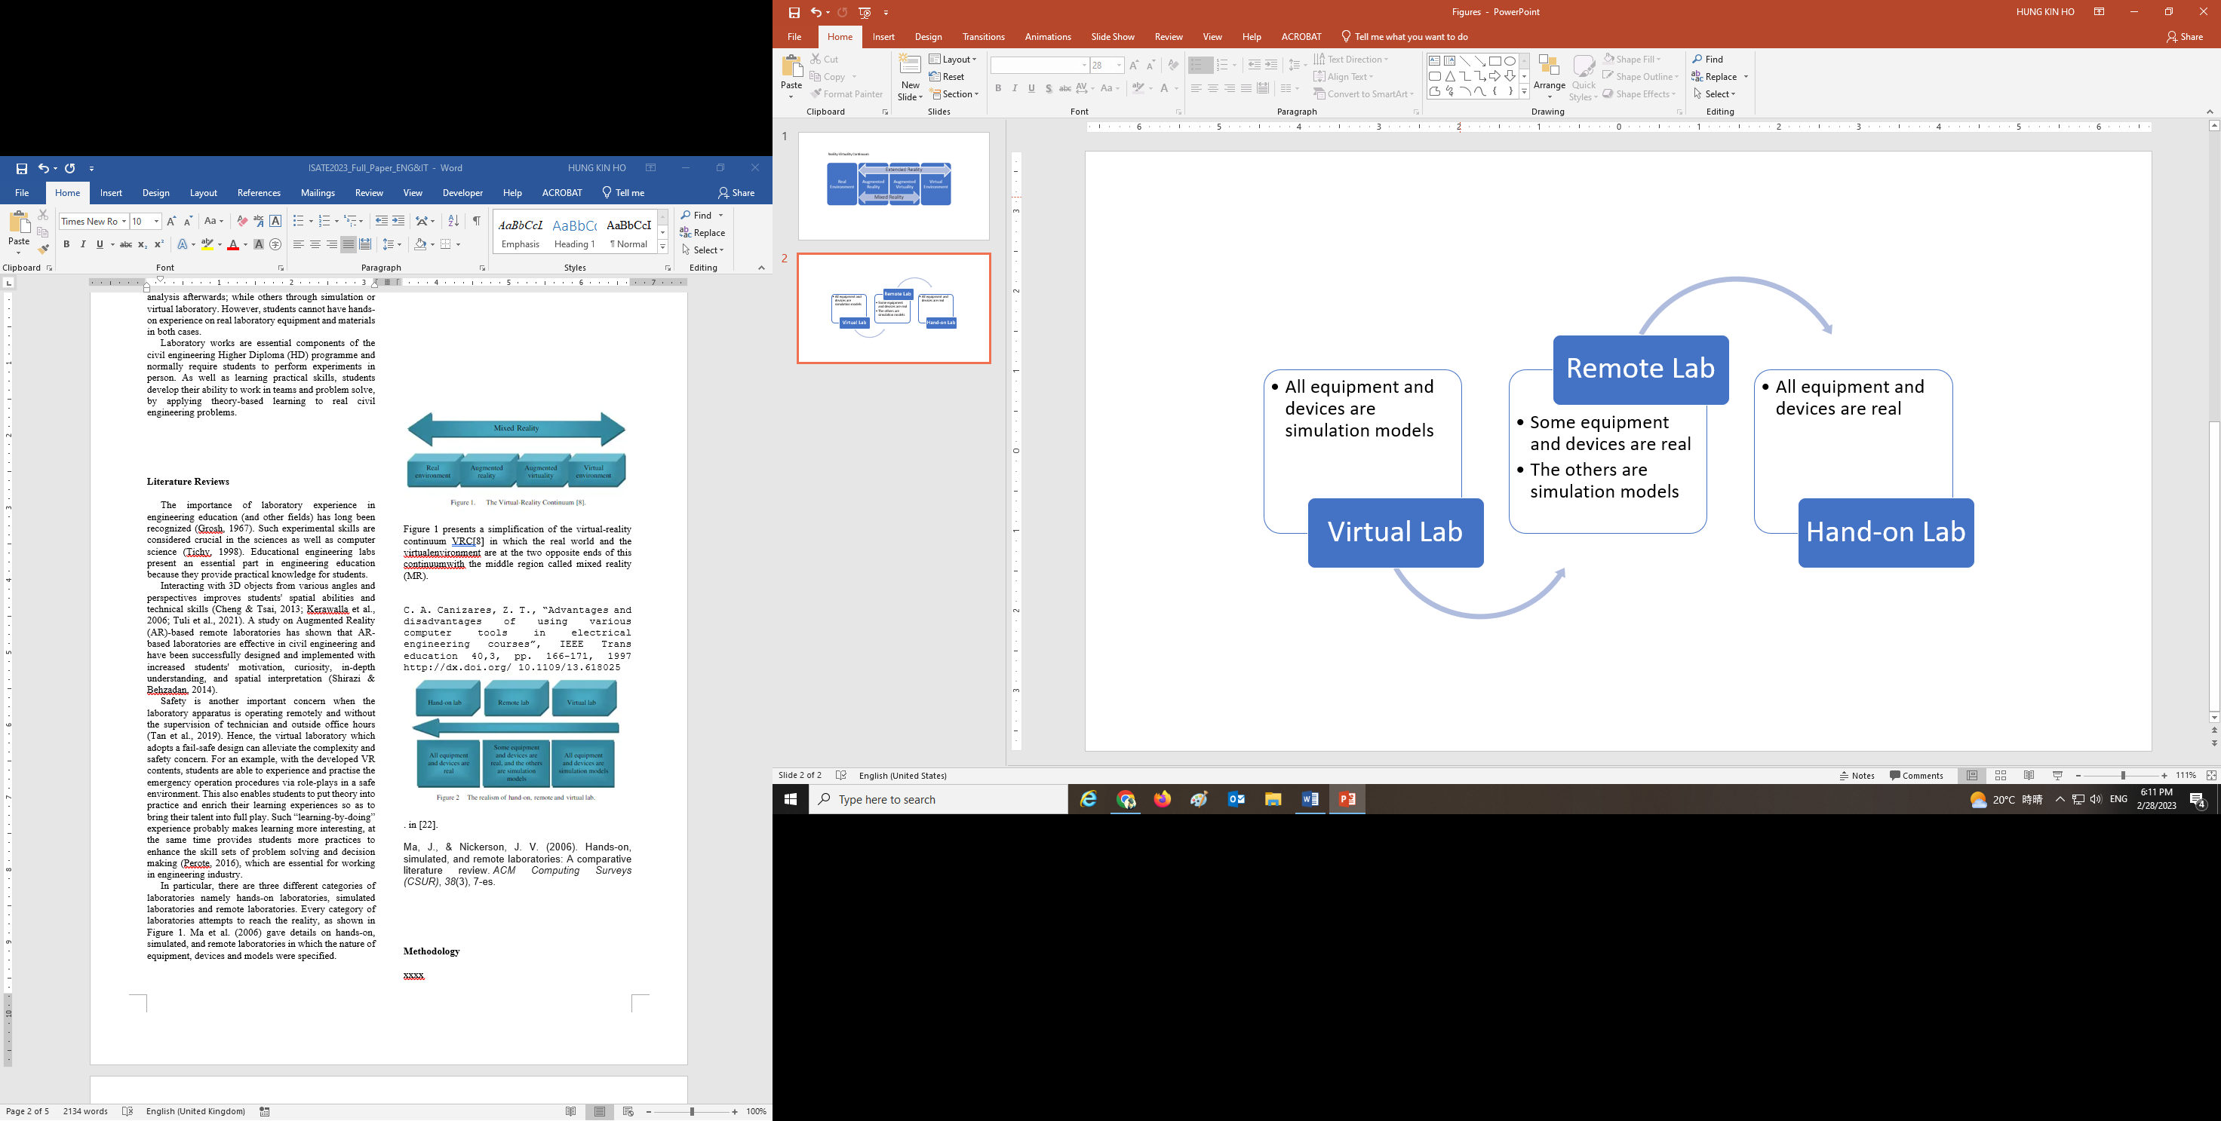

Figure 1. The realism of hands-on, remote and   
virtual laboratories

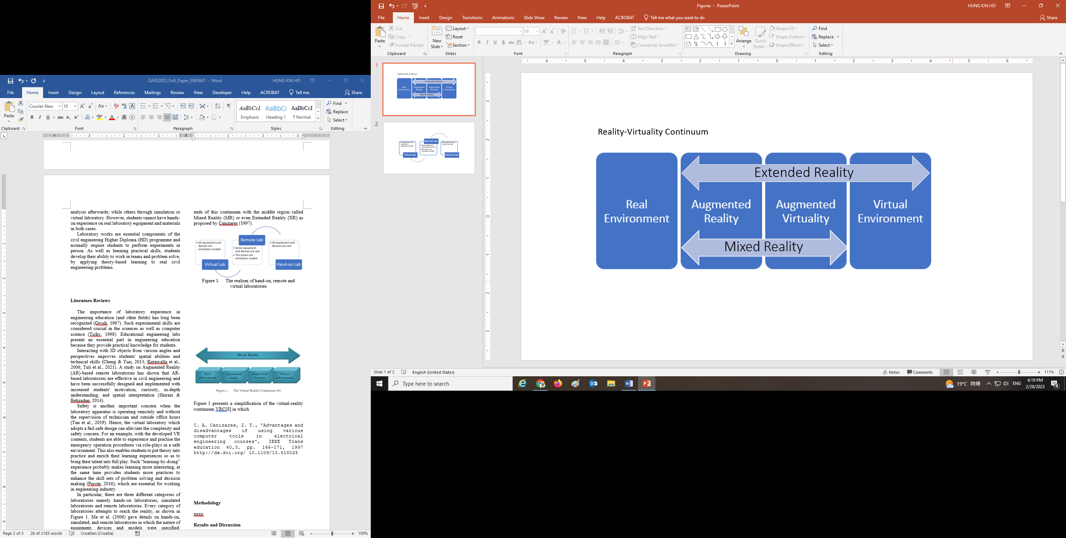

Figure 2. A simplification of the Reality-Virtuality Continuum consisting of MR and XR

**Architecture**

As one of the best alternatives against the cancellation of face-to-face laboratories, virtual laboratories were proposed to perform experiments remotely through a software interface by providing 3D visualization of the laboratory experiments (Figure 3) and allowing students to interact with the learning environments (Figure 4). Students can not only develop their independent learning ability but also experience participation throughout the laboratory (Figure 5). Moreover, virtual laboratories provide flexibility in learning to students without the support of technical staff by providing step-by-step instructions (Figure 6).

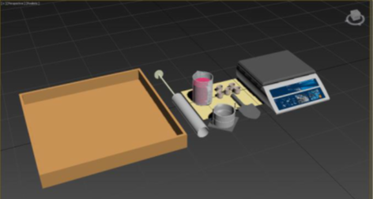

Figure 3. Descriptions of various apparatus were provided to better illustrate the setup.

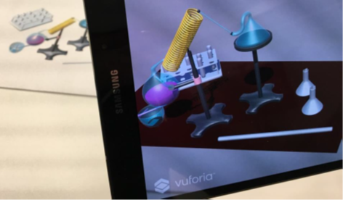

Figure 4. A laboratory was animated with a presentation of streamlined procedures.

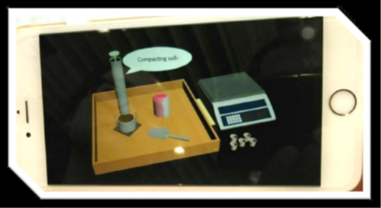Figure 5. A virtual laboratory provided text instructions to students about the experiment.

|  |  |
| --- | --- |
|  |  |
|  |  |
|  |  |

Figure 6. A virtual laboratory approach provides the opportunities for students to learn step-by-step.

**Methodology**

The research was rooted in a quantitative approach by using the online survey as the major data collection tool. The data was analysed based on teachers’ feedback in the engineering discipline. The report aimed to provide findings and recommendations for the future use of virtual laboratories and their development by a reference to quantitative data obtained. Data were collected at the time of the end of COVID-19 in sight (i.e. February to March 2023).

The research methodology involves the evaluation of the survey based on 11 questions with different sections to teachers about their confidence in the sustainability of virtual laboratories and their views on relevant resilience strategies. Eight (8) potential sustainability strategies were proposed in this research to investigate the feasibility of various measures or mechanisms to overcome challenges in the further application of virtual laboratories. The following potential sustainability strategies were included:

1. Integrating virtual labs into the curriculum to enhance the learning experience of students
2. Ensuring the quality and effectiveness of virtual labs in the long term
3. Encouraging faculty members to promote the use of virtual labs and support students in their use
4. Mitigating potential risks and challenges associated with the sustainability of virtual labs
5. Providing continuous support and extension of virtual labs with additional resources and budget
6. Enforcing compulsory enrolment for students in virtual labs
7. Sharing of the virtual labs with other programmes through further developed content that fit their teaching needs
8. Collaborating with other institutes and industrial practitioners through sharing and external participation

The report focused mainly on the teachers’ perspectives and the data collected was a snapshot of a period without reference to any historical data, this can serve as reference information for general, indicative and reference purposes only.

**Results**

A total of twenty-two (N=22) engineering teachers from various departments participated in the survey. When asked about their perception of virtual laboratories, 55% of the respondents agreed that virtual laboratories can provide a valuable addition to the quality of education during the COVID-19 pandemic (Table 1). Moreover, 68% of the respondents agreed that virtual laboratories can provide students with the necessary skills and knowledge to meet the learning objectives of their courses during the COVID-19 pandemic (Table 2).

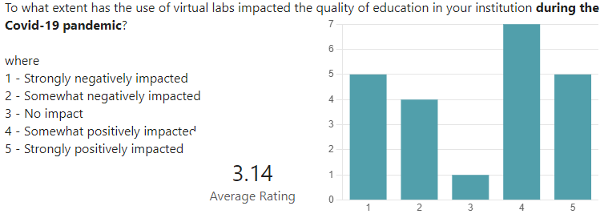

Table 1. Results on the use of virtual labs impacted the quality of education in your institution during the COVID-19 pandemic.

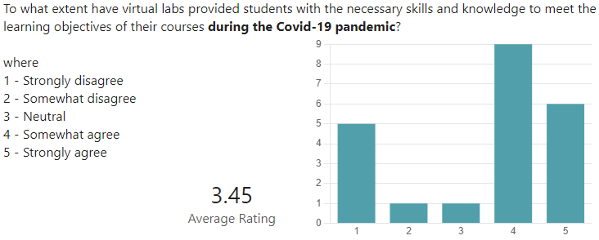

Table 2. Results of virtual labs provided students with the necessary skills and knowledge to meet the learning objectives of their courses during the COVID-19 pandemic.

Without further resource implication in the post-COVID-19 era, the survey results indicated a positive perception of virtual laboratories for the four potential sustainability strategies among engineering teachers. “Encouraging faculty members to promote the use of virtual labs and support students in their use” and “Mitigating potential risks and challenges associated with the sustainability of virtual labs” were more acceptable measures than “Integrating virtual labs into the curriculum to enhance the learning experience of students” and “Ensuring the quality and effectiveness of virtual labs in the long term”. For details, Table 3 gives the breakdown.

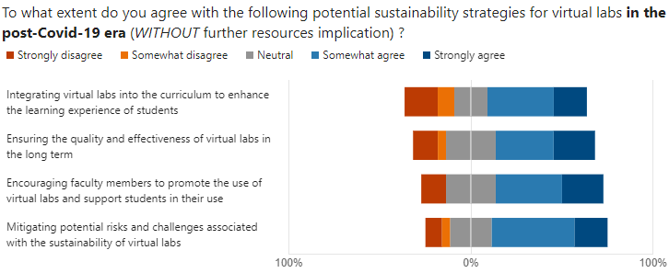

Table 3. Results on potential sustainability strategies for virtual labs in the post-Covid-19 era (without further resources implication)

With further resources implication in the post-COVID-19 era, the survey results indicated a positive perception of virtual laboratories for the four potential sustainability strategies among engineering teachers. “Providing continuous support and extension of virtual labs with additional resources and budget” and “Collaborating with other institutes and industrial practitioners through sharing and external participation” were more acceptable measures than that “Enforcing compulsory enrolment for students in virtual labs” and “Sharing of the virtual labs with other programmes through further developed contents that fit their teaching needs”. For details, Table 4 gives the breakdown.

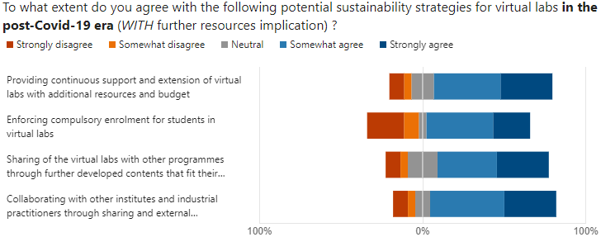

Table 4. Results on potential sustainability strategies for virtual labs in the post-Covid-19 era (with further resources implication)

Overall, the majority of the respondents agreed that some of the proposed potential sustainability strategies for virtual laboratories can generate positive learning outcomes and improve student engagement and motivation.

**Discussion**

According to the research, the views on whether virtual laboratories can generate positive impacts on the quality of education and learning objectives of their courses during the COVID-19 pandemic were diversified. Virtual laboratory resources can be shared among a large community to geographically distributed users with limited setup and operational costs. While virtual laboratories are beneficial from an economic and organizational point of view, it is not clear that they can remain sustainable in the post-covid-19 era. In the case that virtual laboratories will be further developed, resilience strategies for the future use of virtual laboratories must be formulated to promote students' learning effectiveness and the sustainability of these educational approaches.

Firstly, providing resources for teachers to support the use of virtual laboratories in their teaching can be important for increasing access and promoting sustainability. With further resources implication in the post-COVID-19 era, the use of virtual laboratories was demotivated among engineering teachers. Teachers were dissatisfied and unmotivated by an educational goal to make “optimization”. On the other hand, teachers were more satisfied and motivated to employ virtual laboratories if this approach was intended for the “maintenance” of what we had. We modified Herzberg’s Motivation-Hygiene Theory (Herzberg, 2005) to depict how our proposed potential sustainability strategies influenced the teachers’ dissatisfaction and satisfaction through the analysis of hygiene factors and motivator factors, of which they acted independently of each other. We found that ranked in order of priority, a) mitigation measures, b) encouragement measures, c) collaboration measures, d) supporting mechanism, and e) sharing mechanism facilitated teachers’ satisfaction and motivation because they focused on maintaining positive outcomes and reducing negative impacts. Comparatively, we found that, ranked in order of priority, a) actions for integration, b) quality assurance and c) compliance mechanism which focused on optimizing systems and outcomes dissatisfied and unmotivated teachers to use virtual laboratories. For details, readers are recommended to refer to Figure 7.

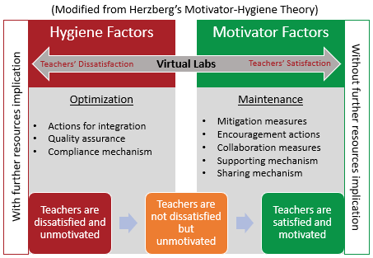

Figure 7. Teachers’ dissatisfaction and satisfaction spectrum over the use of virtual laboratories based on Herzberg’s Motivation-Hygiene Theory

The survey also revealed some of the challenges in promoting virtual laboratories for further use. The most common challenge reported by the respondents was the limitations of virtual laboratories in replicating the physical laboratory experience. Another challenge reported was the reluctance to deploy further resources for the development of quality virtual laboratories. A minority of the respondents disagreed that virtual laboratories can be effective in teaching engineering concepts at all.

**Conclusions**

The pandemic has principally changed the way the higher education sector operates. It has caused a profound shift in how we conduct our teaching, with a large-scale take-up of remote teaching and changes in our digital approach. Among these changes, virtual laboratories were proposed to minizine negative effects on science and engineering teaching and learning as an innovative pedagogical approach at the IVE in Hong Kong.

In post-COVID for engineering education, the further use of virtual laboratories would be uncertain. With the ongoing pandemic, traditional laboratory sessions have become challenging due to physical distancing requirements and limited access to equipment. It is true that virtual laboratories can provide a temporary solution to this problem by allowing students to conduct experiments and practice engineering skills in a simulated environment. However, this technology was also questioned for its ability to expand access to laboratory experiences due to an inadequate level of resource commitment. Engineering teachers perceived the future use of virtual laboratories in their teaching as a dispensable addition to their laboratory work.

Many teachers considered that maintenance of using virtual laboratories out of its current abilities was a preferred option rather than that of optimization of virtual laboratories. Obviously, some teachers may still prefer traditional laboratory sessions, as they provide a more hands-on experience and allow for more interaction between students and instructors.

To effectively sustain virtual laboratories in further use and into the curriculum, if required, institutions should consider the following recommendations. The first essential issue is to provide clear instructions and guidelines for using virtual laboratories. The second issue is to clearly define the use of virtual laboratories to supplement traditional laboratory sessions, but not to replace them entirely. Lastly, it is important to observe feedback from students and teachers before integrating virtual laboratories into the curriculum. By doing so, there is a higher chance of success for virtual laboratories that can not only enhance student learning outcomes by providing a safe and accessible environment for experimentation but also promote active learning by improving student engagement and motivation.

**References**

Azad, A. K. (2007). Delivering a remote laboratory course within an undergraduate program. *International Journal of Online Engineering*, *3*(4).

Cabedo, L., Royo, M., Moliner, L., & Guraya, T. (2018). University social responsibility towards engineering undergraduates: The effect of methodology on a service-learning experience. *Sustainability*, *10*(6), 1823.

Canizares, C. A., & Faur, Z. T. (1997). Advantages and disadvantages of using various computer tools in electrical engineering courses. *IEEE Transactions on education*, *40*(3), 166-171.

Grosh, R. J. (1967). New Directions in Laboratory Instruction for'(Engineering Students. *Engineering Education*, *58*(3), 191-195.

Herzberg, F. (2005). Motivation-hygiene theory. *Organizational behavior one: Essential theories of motivation and leadership, eds JB Miner, ME Sharpe Inc, New York*, *2*(4), 61-74.

Joji, R. M., Kumar, A. P., Almarabheh, A., Dar, F. K., Deifalla, A. H., Tayem, Y., ... & Shahid, M. (2022). Perception of online and face to face microbiology laboratory sessions among medical students and faculty at Arabian Gulf University: a mixed method study. *BMC Medical Education*, *22*(1), 1-12.

Ma, J., & Nickerson, J. V. (2006). Hands-on, simulated, and remote laboratories: A comparative literature review. *ACM Computing Surveys (CSUR)*, *38*(3), 7-es.

Peris-Ortiz, M., Gómez, J. A., Vélez-Torres, F., & Rueda-Armengot, C. (2016). Education tools for entrepreneurship. *Switzerland: Springer International Publishing*.

Tan, Q., Denojean-Mairet, M., Wang, H. et al., “Toward a telepresence robot empowered smart lab,” Smart Learn. Environ. 6, 5 (2019). https://doi.org/10.1186/s40561-019-0084-3

Tichy, W. F. (1998). Should computer scientists experiment more?. *Computer*, *31*(5), 32-40.