**Engineering Education Delivered in a Game-based Virtual Environment**

Lau Zi Rui*

School of Engineering, Ngee Ann Polytechnic, Singapore

*Lau_Zirui@np.edu.sg

**Abstract**

**With the advent of technology and the internet, learners today have become more accustomed to interactive media and self-exploratory learning tools. As such, gamification and self-directed learning approaches can be attractive for learners due to the shift in the way they learn.**

**This paper presents an engineering simulation game built for a module called Thermofluids, offered to Year 1 Common Engineering students in Ngee Ann Polytechnic. The aim of the game is to uplift the teaching and learning of engineering concepts and principles particularly in the domain of Thermofluids by providing students with an engaging, interactive, and self-paced learning experience. The game was developed in-house using the Unity3D game engine that allows for the creation of interactive 3D simulations and games; designed for self-directed learning which permits students to begin at a level that they can understand to construct knowledge at their own pace. The player experiences the game from a first-person perspective and takes up an intern persona who works in a sci-fi themed factory. The gameplay requires the player to complete a series of lessons, tasks and quizzes related to the topic of water pumps and steam systems.**

**An initial small-scale study was undertaken to evaluate the efficacy of this learning approach, two methods were used: an evaluation survey of 200 students and a performance comparison between an experimental group (with exposure to the game) and a control group (with no exposure to the game) in their ability to answer a pump design exam question which requires students to apply their knowledge on sizing the pump to meet certain design specifications. A hypothetical p-test at a 5% significant value was conducted to compare the performance between these two groups. The probability was found to be less than 0.05, indicating convincing evidence that the experimental group's performance was significantly better than the control group, thus further supporting the hypothesis of the game being an effective reinforcement learning tool. In addition, the evaluation survey results showed that 70.5% of students agreed that they were able to understand the engineering concepts presented through the gameplay and 61.5% of students agreed that the game was effective in delivering the concepts to them. This study suggests that the use of gamification and self-directed learning pedagogy in simulation games can be an effective approach for enhancing engineering education.**

**Keywords:** *Engineering simulation game, Gamification, Self-directed learning, Thermofluids, Unity3D, Interactive, Self-paced.*

**Introduction**

Today's students are digital natives who grew up with digital technology and have spent a significant amount of time interacting with computers, video games, and digital devices. This has caused them to think and process information differently than previous generations, having a more visual learning style and limited attention span. Integrating virtual game technology in engineering education can revolutionize the way students learn and perceive engineering. With the advancement of digital technology, students have grown accustomed to a more visual and interactive learning experience. Virtual games provide a dynamic and engaging platform for students to learn and apply engineering concepts, making the subject more attractive and accessible. Various literature such as Wiggins (2016) has highlighted the effectiveness and advantages of using games in education. These engaging games create a low-pressure environment for reviewing, testing, and refining ideas while addressing any misconceptions (Fuentes, Crown, & Freeman, 2008). Additionally, according to Sancho, Torrente, and Fernández-Manjón (2009) virtual games foster the development of soft skills that are highly sought after in the industry, such as communication, teamwork, and problem-solving. By providing an immersive and realistic learning environment, virtual games can bridge the gap between the traditional engineering academia and the evolving industry demands. Moreover, virtual games can help to keep pace with the rapid advancement of technology, allowing students to stay updated with the latest skills and knowledge. Therefore, the use of virtual games not only can make engineering courses more attractive (G. Barata et. al, 2013) but also help to mitigate problems such as decreasing enrollment in engineering programs and lack of creative thinkers among engineering graduates. With such benefits, Ngee Ann Polytechnic’s School of Engineering has begun its early adoption of such virtual game in its engineering curriculum by building an engineering simulation game for a module called ThermoFluid, offered to Year 1 Common Engineering students. This paper shall provide details on the game development and presents the result of a small-scale study to evaluate the effectiveness of the game in enabling students to achieve better learning outcomes.

**Literature**

Developing games for engineering education can involve several different teaching pedagogies, depending on the specific goals and objectives of the game and the intended learning outcomes for the students. Problem-based learning (PBL) is a teaching method that involves giving students a real-world problem to solve and guiding them through the process of finding a solution. In the context of game development for engineering education, PBL could involve giving students a game design problem to solve, such as creating a game that teaches a specific engineering concept. Topalli and Cagiltay (2018) effectively implemented PBL through their real-life game development projects from scratch. Their results indicated significant improvement in student academic performance. Project-based learning (PjBL) is a teaching method that involves giving students a project to work on and guiding them through the process of completing the project. In the context of game development for engineering education, PjBL could involve giving students a project to create a game and guiding them through the process of designing and developing the game. Gamification is the process of using game design elements, such as rewards and points, to make non-game activities more engaging. In the context of engineering education, gamification could involve using game design elements to make learning engineering concepts more engaging and interactive. Gamification has demonstrated advantages in education, benefiting both teachers and students. These benefits, including enhanced engagement, motivation, confidence, attitude, learning perception, and performance, support the use of gamification in higher education (Subhash & Cudney, 2018). Collaborative learning is a teaching method that involves having students work together in small groups to complete a task or project. In the context of game development for engineering education, collaborative learning could involve having students work together in small teams to design and develop a game as shown by Arango et al (2007). Self-directed learning is a teaching method that encourages students to take responsibility for their own learning. In the context of game development for engineering education, self-directed learning could involve giving students the freedom to design and develop their own game and guiding them through the process of self-reflection and self-evaluation. It is interesting to note that many game developments combine multiple pedagogies in their game development such as the one shown by Villagrasa, Fonseca, Redondo and Duran (2014).

**Design and Development**

A methodical approach was employed to design the virtual game. The virtual game will be developed using Unity3D platform. Unity, a widely used game engine, is often used to create virtual environments for DGBL (Digital Game Based Learning) and assessment applications due to its key features like physics and building options, as well as its large user community. (Wang, 2018; Metallaoui et al, 2015; Nguyen et al, 2017). It is a real-time game development platform with a range of applications including gaming, manufacturing, cinematics, engineering, and architecture. It provides tools for creating multi-platform apps, including desktop, console, web, mobile, and VR/AR. The main development tool is the Unity Editor, which allows users to add game objects to the scene, such as characters, models, lighting, cameras, and audio effects. With the goal of enabling students to meet the learning objectives outlined in their diploma, these objectives were extracted and aligned accordingly. A generic storyline was then crafted as the foundation of the game. As the game was intended for Polytechnic Engineering students, who are players in the game, the storyline follows a fictitious engineering student completing an internship at a soda manufacturing company, thus providing familiar and relatable context for the player. The soda manufacturing plant is designed to incorporate learning elements related to thermodynamics and fluid mechanics. The schematic of the plant design is shown in Figure 1 and the actual setup in the game environment is shown in Figure 2 . Within the game, the player will need to go through a progressive increase in difficulty of task to help scaffold the learning process of the player. The entire game requires the player to perform 3 tasks which map to the recall (level 1), apply (level 2), and synthesize (level 3) skillsets under the main thinking skill framework (Su et al, 2011). The following segments will describe the game design in detail.

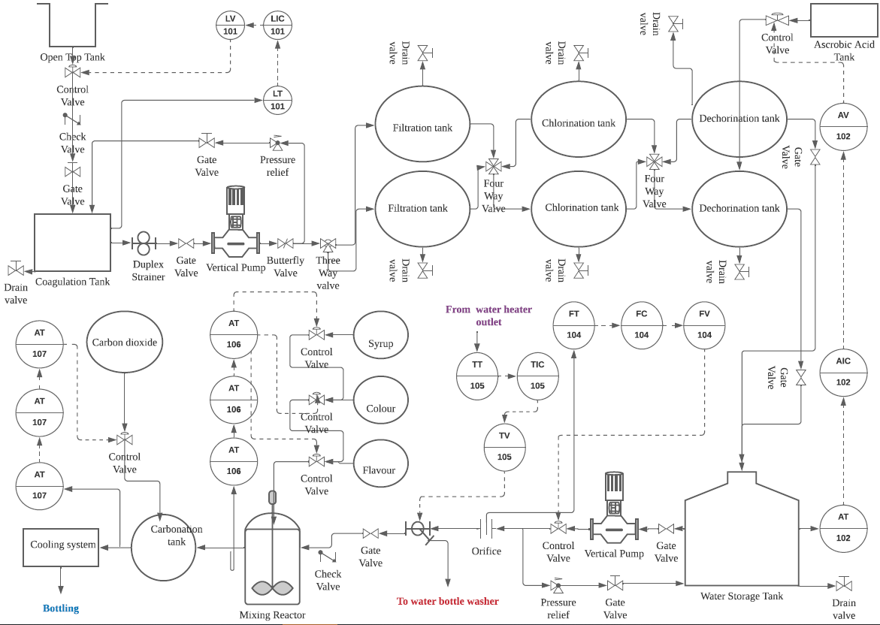

Figure 1: Design schematic of soda plant

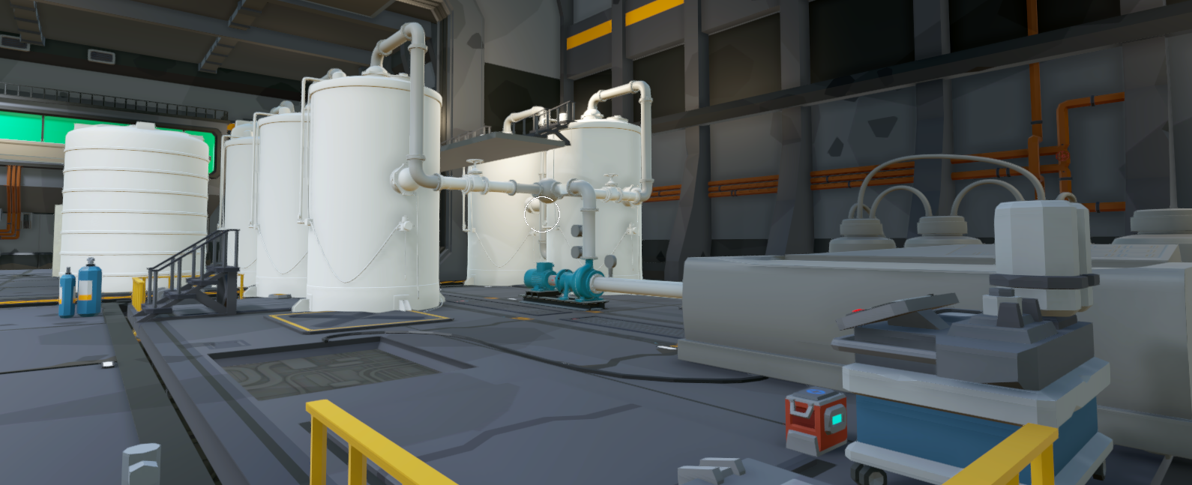

Figure 2: Game environment

Fluid Mechanic Game Design

The Fluid Mechanic game design is divided into three parts and is designed to meet the following learning objectives:

1. Identify different types of pumps and describe their applications, with a focus on centrifugal pumps.
2. Interpret pump curves to obtain parameters for pump sizing.
3. Apply parallel and series pump configurations according to their intended functions.
4. Design and install a backup pump system in case of primary pump failure.

The first part is the competency building phase, where the student, playing the role of an engineering intern, learns about the fundamentals of pumps, pump types, pump curves, and pump installations. The student can complete interactive activities (Figure 3) and learn from the factory personnel during this phase. Once students have completed this phase, they can progress to the next level. In the second level, the student must install pumps in series and parallel configuration as a guided application of the knowledge they have acquired in part one. Upon successful completion of part two, they can move on to part three, where they are required to design and install a backup pump system in case of primary pump failure. If the students fail any part, they will be guided to repeat every part until they get it right.

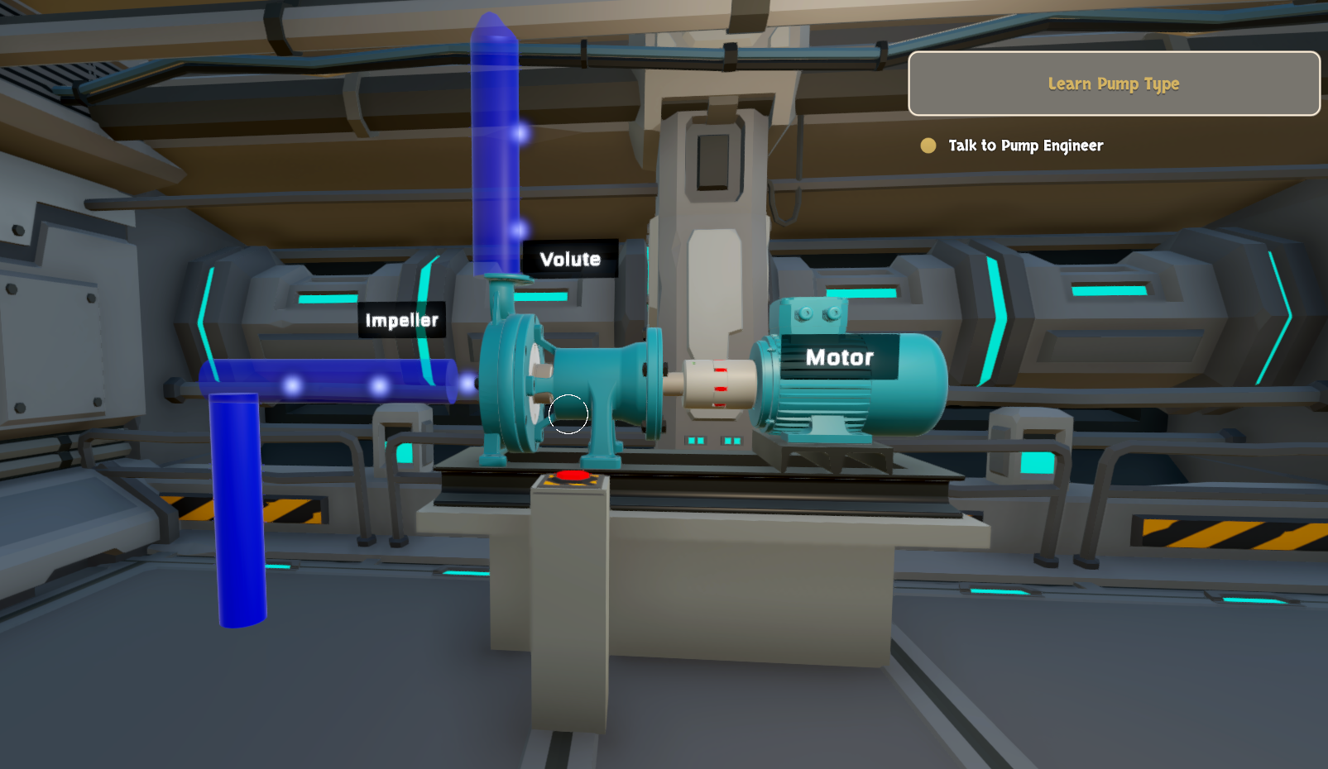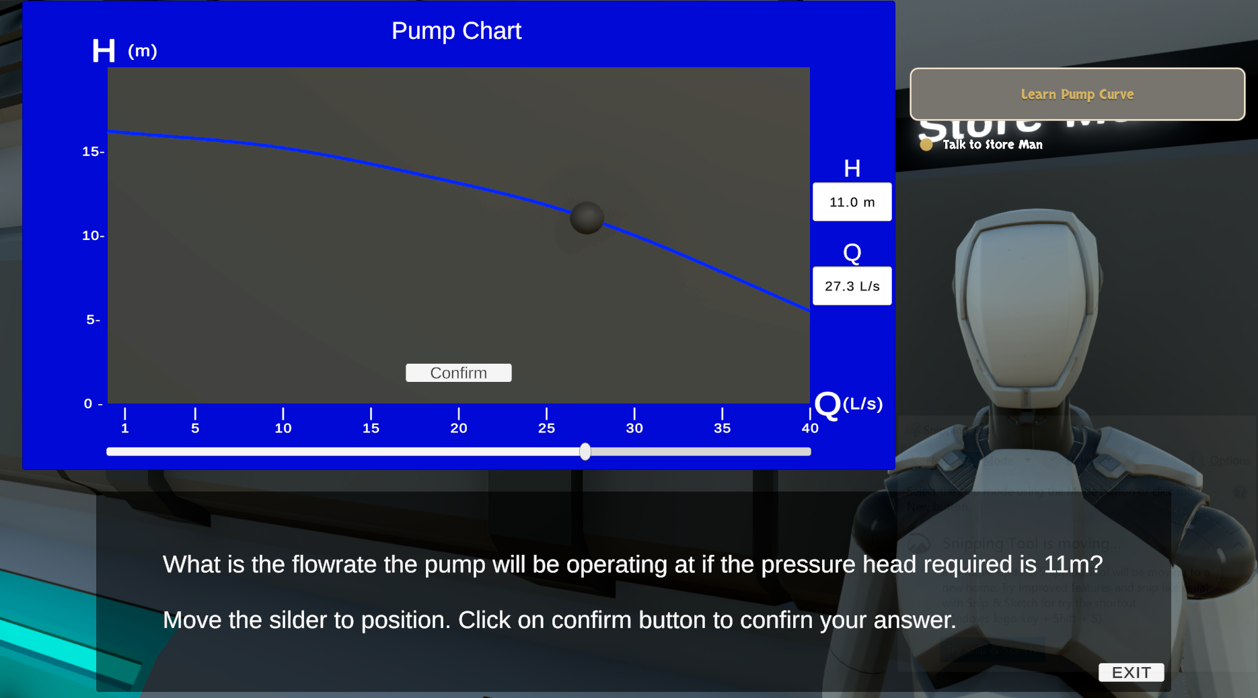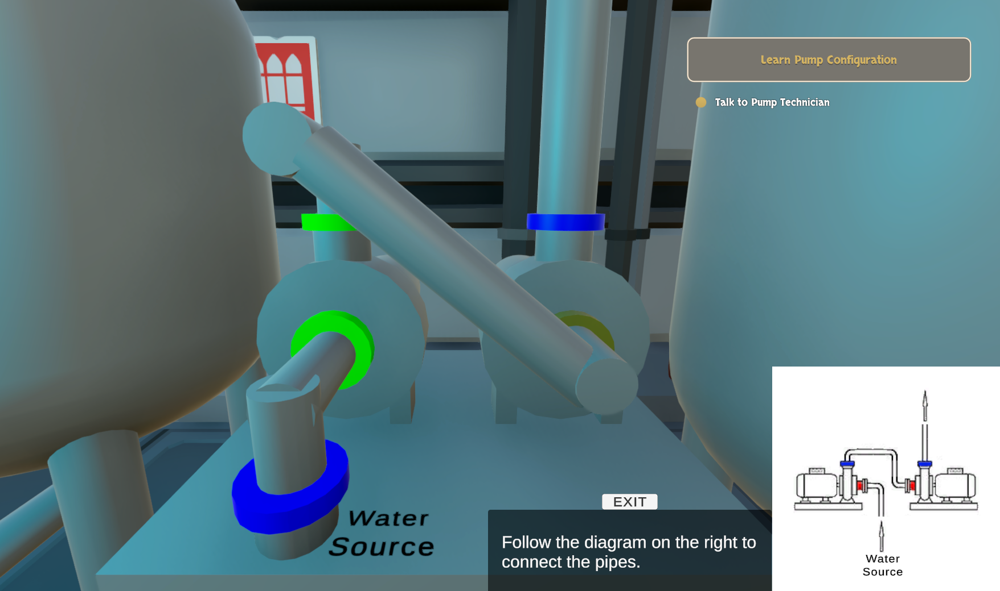

(a)

(b)

(c)

Figure 3: Interactive tasks a) Centrifugal pump configuration; b) Pump Curve; c) Parallel/Series pump

Thermodynamics Game Design

Similarly, the Thermodynamic game consists of 3 levels and is designed to meet the following learning objectives:

1. Describe the properties of steam and its application in a sterilization process.
2. Interpret steam tables.
3. Apply steady-state energy flow equations for heat exchanger sizing.

In level 1, the players must go through a series of interactive tasks which enables them to learn the fundamentals of steam and steam table. Level 2 involves a guided task of adjusting steam parameters to reduce energy consumption of the sterilization process which leads to cost reduction for the plant. After completion of level 1 and 2 tasks, the player will be presented with an advanced problem in which they need to design and implement a heat exchanger system to recover waste heat and reduce energy consumption. The level 3 task requires the player to utilize the same concepts learnt in level 1 and 2 to synthesize the solution and calculate the eventual cost savings and breakeven point of the heat exchanger. The schematic of the level 3 gameplay is shown in Figure 4. Each step taken to solve the level 3 problem is intentionally designed to meet certain subject knowledge (Table 1) so to ensure that the learning objectives of the Thermodynamic package are achieved

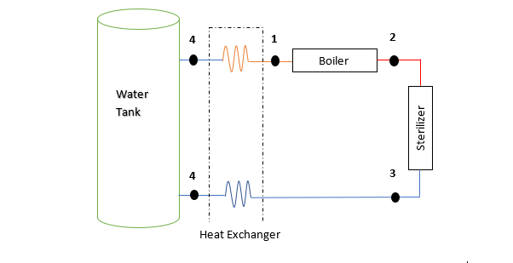

Figure 4: Schematic for heat recovery (level 3 gameplay)

Table 1: level 3 gameplay problem steps

|  |  |
| --- | --- |
| ***Steps*** | ***Subject knowledge*** |
| * Student to check Saturated water and steam table,   **Conclude** the steam from the sterilizer exit is wet steam. | *Use of Saturated water and steam table to determine state of fluid* |
| * Calculate h3 using wet steam formula $$h_{3}=\left(1-x\right)h_{f}+xh_{g} \\ =\left(1-0.5\right)*417+0.5*\left(2675\right) \\ =1546 kJ/kg$$ | *-Use of wet steam formula to calculate enthalpy of wet steam* |
| * Obtain the new $h_{1}^{'}$ $$Heat absorbed at the cold side=Heat lost at the hot side$$ $\dot{Q_{in}}=\dot{Q_{out}}*hex efficiency$ $$\dot{m(}h_{1}^{'}-h_{4})=\dot{m(}h_{3}-h_{4})*ε \\ 0.3\left(h_{1}^{'}-108.9\right)=0.3\left(1546-108.9\right)*0.9 \\ h_{1}^{'}=1391.4 kJ/kg$$ | *Demonstrate the use of Steady Flow Energy Equation*  *Apply thermal efficiency of the heat exchanger* |
| * **Calculate** New Energy consumption = boiler heat input, $$\dot{Q_{new}}=\dot{m}\left(h_{2,new}-h_{1}^{'}\right) \\ =0.3*\left(2707-1391.4\right) \\ =394.68 kW$$ | *Demonstrate the use of Steady Flow Energy Equation* |
| * **Calculate** energy savings, $$Energy Savings \\ = 793.23 kW*12*30-$$ $$394.68 kW*12*30 \\ = 143478 kWh$$ $$\%energy reduction \\ =\frac{143478}{285562.8}*100 \\ =50.2\%$$ $$Cost savings \\ =143478*0.3 \\ =\$ 43043$$ | *Conversion of kW to kWh*  *Energy savings calculation*  *Cost savings calculation* |

Both games were developed within the same application and students can choose which game they wish to start with. Upon starting, each package is designed to be sequential, and the student can only be certified as completed when they have successfully solved all three parts. Figure 5 provides a clear overview of how the various parts of the game are connected and how the student can progress through the game.

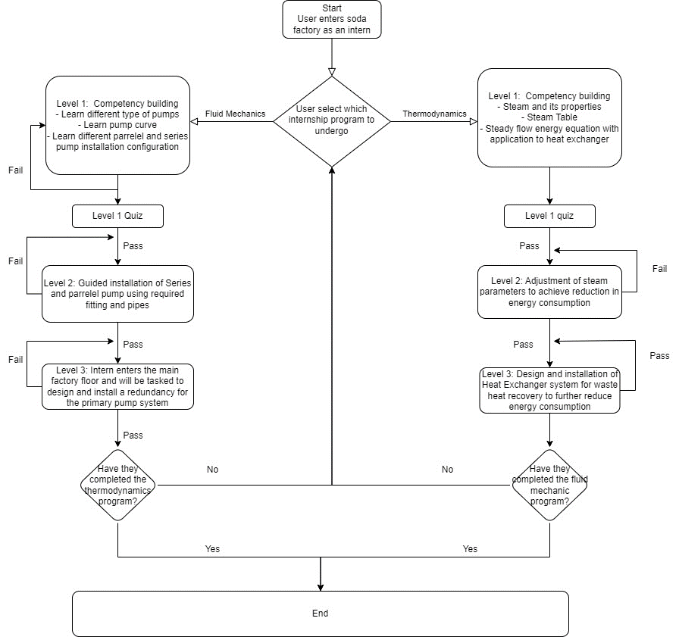

Figure 5: Gameplay flowchart

**Results and Discussion**

The effectiveness of the virtual game in supporting engineering students to learn ThermoFluid concepts and its impact on students' academic performance was examined in 3 ways. 1. Student survey, 2, Qualitative responses, 3. Control group study where students' performances in those that played the virtual games were reviewed against those that did not. In the first part, the quantitative results of a student survey will be discussed. This survey aimed to evaluate the effectiveness of the virtual game as a tool for teaching engineering concepts. The second part of this segment will focus on individual qualitative responses obtained from the student survey, which will be used to improve the game mechanics in future iterations. The students' feedback and suggestions will be evaluated and incorporated into the next iteration of the game to enhance its effectiveness and learning engagement. Finally, the third part of this segment will be a control group study. The aim of this study is to examine whether there is a correlation in the actual academic performance improvement between students who played the virtual game and those who did not. Overall, this segment will provide a comprehensive evaluation of the virtual game and its potential to enhance student learning and engagement in ThermoFluid engineering.

Student survey

The survey questions consisting of 2 binary question and a 2 Likert scale questions (Table 2) were designed to collect information on several key aspects of the game's performance, including its ability to deliver the necessary information to complete the game, its effectiveness in teaching ThermoFluid concepts, and its ability to motivate and reinforce learning. The survey results showed that most students were able to find the information needed to complete the game, with 89.4% of respondents reporting success in this regard. Additionally, all students who completed the game were able to correctly answer 2 lower order “recall” type verification questions related to series and parallel pump installation, centrifugal pump operation, and backup pump installation. These findings suggest that the game was successful in delivering the necessary information to students. In terms of the game's effectiveness in teaching ThermoFluid concepts, most students felt that they were able to learn the concepts, with 70.5% indicating success in this regard. Among the 70.5% who replied yes, an overwhelming majority of students (87.2%) gave a score of 3 and above (out of 5) when they were asked if they felt that the game had effectively delivered the concepts to them. The survey also revealed that the students were more motivated to learn in the game-based environment, with an average score of 4.1 out of 5 for this question. The majority of students spent between 15-30 minutes completing the game. This duration is indicative of the game's ability to deliver the required information and concepts efficiently. It is noteworthy that while students indicated good master in the topic covered by the game, they did not spend an excessive amount of time on the game, hence, indicating that the game was concisely designed and effective in delivering the necessary material.

Table 2: Survey questions and results

|  |  |  |
| --- | --- | --- |
| ***No.*** | ***Survey Question*** | ***Results*** |
| 1 | Were you able to find the information required to play the game? | Yes (89.4%); No (10.6%) |
| 2 | Was this game useful in helping you understand the topic | Yes (70.5%); No (29.5%) |
| 3 | How well did the game teach the engineering concepts it covered?  (Of those who answered yes to  qns 2) | 87.2% providing score of > 3 out of total score of 5 |
| 4 | How well did the game motivate you to learn more about engineering | Average score: 4.1/5 |

Overall, the survey results suggest that the virtual game is a useful tool in teaching ThermoFluid engineering concepts to engineering students. The game successfully delivered the necessary information and concepts, and most students felt that they learned the ThermoFluid concepts effectively from the game. Importantly, the game-based environment was found to be more motivating for the students. The duration spent on the game suggests that it is a time-efficient way of delivering the necessary content. These findings indicate that the virtual game can supplement traditional classroom instruction in ThermoFluid engineering.

Student individual feedback response

The feedback provided by players on the game was extensive, covering various areas for improvement. Players highlighted the importance of clarity and instructions, recommending the addition of a dialogue history and clearer instructions on how to connect the pipes. They also expressed a desire for different modes of play, such as a story or career mode, and multiplayer gameplay to increase engagement and teamwork. In addition to the feedback on clarity and modes of play, players also recommended improving the game's settings. Specifically, players suggested improving the controls and mouse sensitivity to make the game more user-friendly and responsive. Additionally, players suggested adding more settings to the game to enhance the player experience. Some examples of the requested settings included options to customize the graphics quality, adjust the sound effects and music volume, and toggle different display options such as screen resolution and aspect ratio. Players also suggested the addition of more advanced settings for experienced players, such as the ability to fine-tune graphics settings and tweak gameplay mechanics. By offering a wider range of settings, players believe that the game could cater to a larger audience and provide a more personalized gaming experience. In terms of content, players wanted more scenarios from real-life industries and more learning points. They also suggested the addition of different chapters to the menu screen, a currency system, and making the game available as a mobile app to further increase engagement. While some players reported lag and performance issues, the technical aspects of the game were not given top priority, as educational value was the focus. However, players did suggest the optimization of graphics, frames, and game mechanics, and the addition of background music and a water-shooting mini-game related to the pump system to improve engagement and appeal. Lastly, players recommended making the pumps and pipes observable to enhance the educational value of the game, adding more colors and characters, improving the simulations, and giving the in-game robot a human face. Overall, the feedback provides valuable insights into areas for improvement and potential areas for further development and expansion of the game

Control group study to assess academic performance correlation

The study utilized a post-test control group design involving 432 students, who constituted the entire cohort enrolled in the Thermofluids module. With three weeks remaining before the final examination, all 432 students were notified about the availability of a game through Ngee Ann Polytechnic's learning management system (LMS) and were encouraged to participate in it. The game was positioned as a learning enhancement tool aimed at improving their comprehension of pump and pump system design. Two separate reminders were broadcasted via the LMS to prompt the student to complete the game. At the end of the three-week period, 200 students engaged with the game, while the remaining 232 students abstained, forming the control group for the study.

To assess the correlation between the virtual game and students' academic performance, the examination scores of both groups were compared using a normalized score derived from a specific examination question assessing pump and pump system design. The experimental group exhibited mean and median scores of 66.5 and 67, respectively, whereas the control group displayed mean and median scores of 61.3 and 63.5, respectively. These findings indicated a statistically significant improvement in the experimental group's performance, with mean and median assessment scores exhibiting an 8.48% and 5.51% increase, respectively, compared to the control group. Furthermore, the disparity in scores between the experimental and control groups was analyzed using a Gaussian distribution of the weighted probability of scores (Figure 6), illustrating a significant performance improvement for the experimental group. To test the statistical significance of the results, a hypothetical t-test was conducted with a significance level of 5%. The resulting probability was calculated as 0.0435, which falls below the selected significance level of 0.05. This outcome provides compelling evidence that the experimental group's performance was significantly superior to that of the control group.

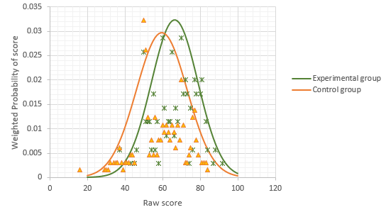

Figure 6: Gaussian distribution base on the weighted probability of scores

**Conclusions**

In conclusion, this study's findings support the potential of incorporating a virtual game into engineering education to enhance students' learning of ThermoFluid concepts. The virtual game demonstrated effectiveness as a supplementary learning tool, facilitating knowledge acquisition and contributing to improved academic performance. However, it is important to acknowledge that the virtual game utilized in this study was still in the prototype stage. Therefore, further investigations are warranted to explore the academic correlation of implementing a mature version of such a game within the curriculum. Furthermore, the study acknowledges a limitation inherent in the control group design, specifically concerning the students who abstained from participating in the virtual game. It is recognized that these students may have possessed lower academic abilities or lacked motivation, which could have influenced the study outcomes. To enhance the significance of future research in this area, it is recommended to conduct statistical profiling of students based on their past academic records before conducting group comparisons to ensure greater homogeneity in academic abilities. Additionally, conducting longer-term studies would yield more robust and stable results, allowing for a comprehensive assessment of the sustained impact of the virtual game.

Despite this limitation, the present study serves as a valuable reference point, highlighting the potential benefits of reinforced learning through the integration of an engineering virtual game. The outcomes indicate that incorporating a virtual game in engineering education can be an effective strategy for improving academic performance and enhancing students' understanding of ThermoFluid concepts. As such, this study provides support for the exploration and implementation of virtual games in engineering curricula, with the aim of fostering enhanced learning outcomes.

**References**

Arango, F., Chang, C., Esche, S. K., & Chassapis, C. (2007, October). A scenario for collaborative learning in virtual engineering laboratories. In 2007 37th annual frontiers in education conference-global engineering: knowledge without borders, opportunities without passports (pp. F3G-7). IEEE.

Barata, G., Gama, S., Jorge, J., & Goncalves, D. (2013). Engaging engineering students with gamification. In 2013 5th International Conference on Games and Virtual Worlds for Serious Applications (VS-GAMES) (pp. 1-8). IEEE. doi: 10.1109/VS-GAMES.2013.6624228.

Douglass, C., & Morris, S. R. (2014). Student perspectives on self-directed learning. Journal of the Scholarship of Teaching and Learning, 13–25.

Fuentes, A., Crown, S., & Freeman, B. (2008). AC 2008-2056: Human bone solid mechanics challenge: functionally graded material structure with complex geometry and loading. page, 13, 1.

Matallaoui, A., Herzig, P., & Zarnekow, R. (2015). Model-Driven Serious Game Development Integration of the Gamification Modeling Language GaML with Unity. In 48th Hawaii International Conference on System Sciences (HICSS), HI, USA (pp. 643–651). IEEE.

Nguyen, V. T., & Dang, T. (2017). Setting up Virtual Reality and Augmented Reality Learning Environment in Unity. In Adjunct proceedings of the 2017 IEEE International Symposium on Mixed and Augmented Reality, Nantes, France (pp. 315–320). IEEE.

Subhash, S., & Cudney, E. A. (2018). Gamified learning in higher education: A systematic review of the literature. Computers in Human Behavior. <https://doi.org/10.1016/j.chb.2018.05.028>

Su, W. M., & Osisek, P. J. (2011). The revised Bloom’s Taxonomy: Implications for educating nurses. The Journal of Continuing Education in Nursing, 42(7), 321-327.

Topalli, D., & Cagiltay, N. E. (2018). Improving programming skills in engineering education through problem-based game projects with scratch. Computers & Education, 120, 64-74.

Villagrasa, S., Fonseca, D., Redondo, E., & Duran, J. (2014). Teaching case of gamification and visual technologies for education. Journal of Cases on Information Technology (JCIT), 16(4), 38-57. DOI: 10.4018/jcit.2014100104

Wang, D. (2018). Gamified learning through unity 3D in visualizing environments. Neural Computing and Applications, 29(5), 1399–1404. https://doi.org/10.1007/s00521-017-2928-5.