**ASYNCHRONOUS LECTURES FOR EEE ENGINEERING STUDENTS – WHAT WORKS**

Soo Bee Hong*,a, Lim Joo Ghee a, Safura Anwar a, and Toh Ser Khoonb

a Singapore Polytechnic/School of Electrical & Electronic Engineering, Singapore

b Singapore Polytechnic/Department of Industry & Partnerships, Singapore

*Soo_Bee_Hong@sp.edu.sg

**Abstract**

**This paper presents the implementation of asynchronous lectures in the School of Electrical and Electronic Engineering (SEEE) at Singapore Polytechnic. The COVID-19 pandemic in 2020 has led to a sudden shift from traditional in-person lectures to fully asynchronous online lectures in the school. Guidelines were established for staff in developing such content to ensure consistency in the development, which emphasizes segmenting learning content into bite-sized videos, along with generative activities such as knowledge check questions and Self-Reflective Quizzes. The development of asynchronous lectures adheres to the basic principles of multimedia learning for students. These contents were progressively enhanced with multimedia and interactive elements such as animated graphics and interactive hotspots. However, such enhancements were often resource intensive. Thus, it was necessary to understand how the students perceive the created asynchronous lectures and which aspects they prefer that were beneficial for their learning experience to guide further development. To determine the effectiveness of these lectures and identify areas for improvement, SEEE conducted a survey in May 2022, which received 1214 responses from the students across all three years of the four diplomas in the school. Analysis was performed on the data stratified via the students' preferred mode of lecture delivery. The results of the study revealed that students found generative activities such as knowledge checks questions and Self-Reflective Quizzes beneficial to their learning; they also preferred short videos. Students also expressed the desire for the lecturer's "social presence" in the asynchronous lectures and the importance of having their questions answered during the learning process. The study also looked at the impact of the change in the delivery mode on the student performance. The results suggest improvements in the existing asynchronous lectures and their further developments. The paper offers recommendations for creating engaging asynchronous lectures that meet the needs of the students while considering the limited resources of the school's teaching staff.**

**Keywords:** *e-learning, asynchronous lectures, interactivity, multimedia learning*

**Introduction**

The COVID-19 pandemic and the imposition of a nationwide partial lockdown in April 2020, known as the ‘Circuit Breaker’, necessitated full home-based learning for all schools and institutes of higher learning (IHLs) in Singapore. For the School of Electrical and Electronic Engineering (SEEE) at Singapore Polytechnic, it made a complete switch to full flipped learning. This required the conversion of all learning contents previously delivered through face-to-face (F2F) lectures to asynchronous online content using recorded video lectures. Some modules also incorporated interactive multimedia elements to better engage students. All tutorials were conducted as synchronous sessions online until the ‘Circuit Breaker’ was lifted in early June 2020. Eventually, F2F lectures were replaced across the board by asynchronous lectures in October 2020.

The teaching faculty poured in concerted efforts in the creation of the asynchronous lectures to ensure that student learning was not compromised while studying from home during the initial stage of the pandemic. As part of ongoing continuous improvement, the school had the support of a non-academic development team to work with the module domain specialists to further improve the asynchronous lecture materials since September 2020.

This paper aims to study how the students view the asynchronous lectures created and which aspects of these contents were effective for the students’ learning experience. The results obtained would help guide further development in this area.

**Development of asynchronous learning contents**

In early 2020, the school provided guidelines for teaching staff on the creation of the asynchronous learning content. This is to ensure uniformity and consistent implementation for the more than 100 modules offered by the school. Each topic of a module should have the following:

•Learning Outcomes

•Revision of pre-requisite knowledge (if applicable)

•Lesson materials with “Knowledge Check”

•Illustrative Examples

•Self-Assessment (Self Reflective Quiz)

•Summary

•Further Reading

Lesson materials should be in 5 to 10-minute segments. Non-graded knowledge checks were included so that students could gauge their own understanding of the contents, termed as Self-Reflective Quizzes (SRQs). To ensure that students complete these knowledge checks before the synchronous tutorials, a nominal grade of 5% to 10% was allotted for the SRQs. The SRQs also help teaching staff better monitor student learning and provide just-in-time appropriate learning interventions during the synchronous lessons and/or the practical sessions.

While working from home, the teaching staff employed various means to create the recorded video lectures. The use of voice-over PowerPoint slides was the most common approach due to their familiarity with these. This approach offers increased student engagement and satisfaction during asynchronous online learning (Draus et. al., 2014). However, without access to a recording studio or a quiet space, the audio recordings embedded in the PowerPoint slides came with background noise interferences, such as the occasional dog barking or traffic noise. These required frequent re-recording to minimise such distractions, increasing the time spent on such efforts. A few staff expressed reservations about using their voices as they were uncertain if students would receive their narrations positively. Some staff thus resorted to using text-to-speech narration to read prepared scripts. Nevertheless, all the online learning content created followed the guidelines suggested by the school, as shared earlier.

The use of the recorded video lectures seemed to suggest that the students might be having a passive learning experience with e-learning Level 1 interactivity (Community Team, n.d.). While incorporating the knowledge check and quizzes (SRQs) necessitates students interacting with the e-learning materials to perform in classes, it does little to guide teachers in content creation, especially in improving various aspects of learning materials to better ensure student learning and retention.

The literature suggests that interactivity in multimedia content helps facilitate deep learning by actively engaging the learner in the learning process; students also perceive them to be more enjoyable (Evans & Gibbons, 2007; Ha & Im, 2020). Subsequently, the next stage of development of the asynchronous learning content focused on incorporating e-learning level 2 interactivity such as hotspots, drag and drops, as well as multimedia elements such as animated graphics.

To achieve a higher level of e-learning interactivity in the online learning content, module specialists, with the support of the non-academic development team, worked to improve the multimedia content and added interactivity features. For example, the team edited and removed distracting audio content from the recorded video lectures and voice-over PowerPoint slides for a better student learning experience. Enhancements were made to the graphical contents, including figures, diagrams, flowcharts, and schematics to be of a better quality. Other enhancements to the digital contents also included interactive tabs and other multi-modal displays to capture the attention of students. While incorporating interactive multimedia content was desirable for students to learn engineering modules online, the tasks were often resource intensive. These required iterative steps and close consultation between module specialists and the development team, who were not engineering-trained though versed in media design.

The development of asynchronous lecture contents adheres to the basic principles of multimedia learning for students (Mayer & Fiorella, 2022). Two examples are shared here to illustrate how such multimedia content was done. Example 1 was resource-intensive and required staff well-versed in animation creation, and example 2 involved fewer intensive steps, which might arguably provide a similar student-positive experience.

*Example 1*: The module specialist narrated a script for a recording, which was then included in a PowerPoint for a voice-over. The voice-over was then aligned to an animated cartoon video created by the support staff using software such as PowToon (voice principle and temporal contiguity principle).

*Example 2*: The module specialist recorded a lecture on Microsoft Teams. As part of his lecture, he used the laser pointer at appropriate times to build up the explanation of a circuit (signalling principle and voice principle). The media staff then added captions to the video lecture recording (spatial contiguity principle).

To avoid redundancy, key points are emphasized, and simple diagrams are left for students to process themselves. This avoids overloading students with redundancy (redundancy principle).

Incorporating animated cartoon video, as described in example 1 above, required specialized media design knowledge. In comparison, the approach in example 2 could be used for simple concepts and less challenging to adopt and implement by the module specialists.

**Method**

Given the School-wide implementation of asynchronous lectures in SEEE, it was critical to gather students’ views and opinions on these and their preferences for their learning. An email invite containing a video and a survey link was sent to all SEEE students in May 2022. They were asked to watch the video before completing the survey. They were informed about the aims of the study, and participation was voluntary, hence, informed consent could be assumed. Students needed to use their ichat accounts to authenticate their participation. A total of 1214 students participated in the survey.

**Design of the survey**

This section discusses specific aspects of the survey. It consists of five multiple-choice questions, four opened-ended questions, and one multiple-statement with a 5-point Likert scale, with 1 being “Not at all effective” and 5 being “Extremely effective”.

To gather students’ preferences on the type of recorded video lectures, a question was included, tethered to the short video on the five prevalent types of recorded video lectures used in SEEE. Figure 1 shows the image as part of the question to ensure the students were clear on these different types.

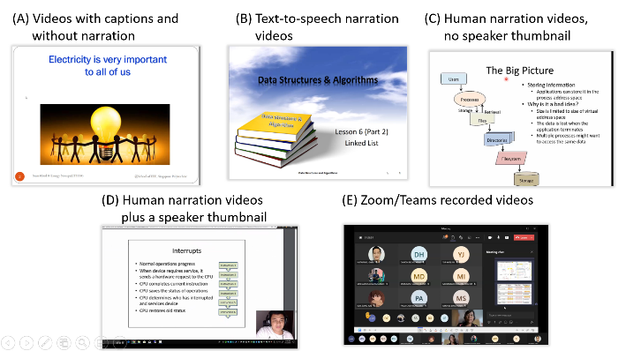

Figure 1. Five Prevalent Types of Videos Produced by Lecturers in Question 5 of the Survey

A similar approach was used for another question to gather their preferences on the types of interactive multimedia content. A short segment of the video illustrates the different types, and an image showing all these types was also included (Figure 2). Examples 1 and 2 discussed earlier are shown to the students as (B) and (C).

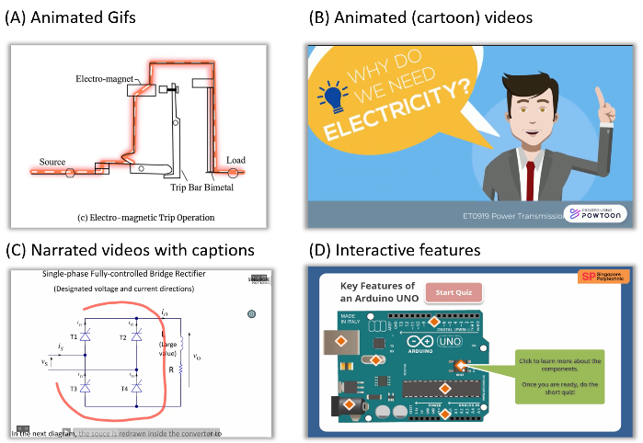

Figure 2. Four Common Types of Interactive Multimedia Content as Part of Question 6 of the Survey

A question on the preferred mode of lecture delivery was included in the survey. By design, to obtain students’ true preferred mode of lecture delivery, an option offered was F2F lectures, although these have given way to online asynchronous lectures since April 2020. The aim was to uncover the reasons for such preference, if indicated. The results would be useful to guide on the aspects of F2F lecture that students could have missed because of asynchronous lecture implementation. Such dimensions could be included as a continuous improvement of asynchronous learning content in further development.

The survey also looked at the impact of the change in the delivery mode on the students' performance. The AY2022/2023 Semester One GPA (Grade Point Average) was extracted to examine whether the student's academic performance correlates with the time spent on the asynchronous lectures. The question on the time spent on the asynchronous lectures aims to assess whether students are using the developed contents. This also provides teaching staff the much-needed confidence that the vast amounts of effort required to do a content overhaul was indeed worth their time.

**Results**

This section discusses the results obtained from the survey.

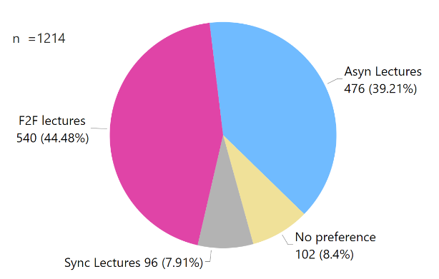

Figure 3. Students’ Responses to the Preferred Mode of Lecture Delivery for Question 1

Figure 3 shows that 39.21% of students chose asynchronous lectures, and a slightly higher percentage of 44.48% preferred F2F lectures.

Table 1 shows the top two common reasons for their preferences. Of the students who chose asynchronous lectures, 65.1% gave the reason that they like the flexibility of learning anytime, anywhere and at their own pace, and 21.2% liked the opportunity to review the difficult concepts by watching the videos again. Of the students who chose F2F lectures, 55.2% indicated that they could have their questions addressed by the lecturers during the lectures, and 30.7% thought that they could focus and learn better.

On the preferred type of recorded video lectures (Figure 4), 34.8% of the students preferred the human narration provided by the teaching staff, and 26.5% preferred the human narration of the teaching staff and simultaneously be able to view them in the thumbnail as a part of the recorded lectures. The least preferred type was text-to-speech narrated video lectures, with only 7.1% of the students indicating so. This result aligns with the Social Cues principle in multimedia learning (Mayer & Fiorella, 2022).

Table 1. The top two common reasons given by the students on the Preferred Mode of Delivery

|  |  |  |  |  |
| --- | --- | --- | --- | --- |
|  | | Number of Students | Percentages in  group | Overall percentage |
| Reasons for choosing asynchronous lectures | |  |  |  |
|  | Like learning anytime, anywhere, and own pace | 310 | 65.1% | 25.5% |
|  | Can review by watching video again | 101 | 21.2% | 8.3% |
|  | Other reasons | 65 | 13.7% | 5.4% |
| Total | | 476 | 100% | 39.2% |
| Reasons for choosing face-to-face Lectures | |  |  |  |
|  | Can interact with the instructor and ask questions | 298 | 55.2% | 24.5% |
|  | Can focus and learn better | 166 | 30.7% | 13.7% |
|  | Other reasons | 76 | 14.1% | 6.3% |
|  | Total | 540 | 100% | 44.5% |

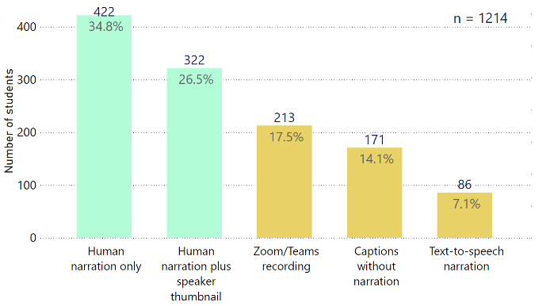

Figure 4. Students’ Responses to the Preferred type of Recorded Video Lectures for Question 5

Figure 5 shows the students’ responses to the effectiveness of the various elements and features found in interactive multimedia asynchronous content. The chart shows that over 56.0% of the students indicated that all these features were extremely effective or very effective. Narrated videos with captions, mentioned earlier as *example 2*, garnered the highest percentage of 78.5% as extremely effective or very effective. The results assured that the efforts to incorporate interactivity helped increase the effectiveness of the learning content as perceived by students. The students’ responses to the effectiveness of bite-sized(short) videos, Graded SRQs, and Non-graded knowledge check questions as extremely effective or very effective in helping them learn were 68.7%, 67.05% and 76.53%, respectively. The percentage obtained was the highest for the non-graded knowledge check questions.

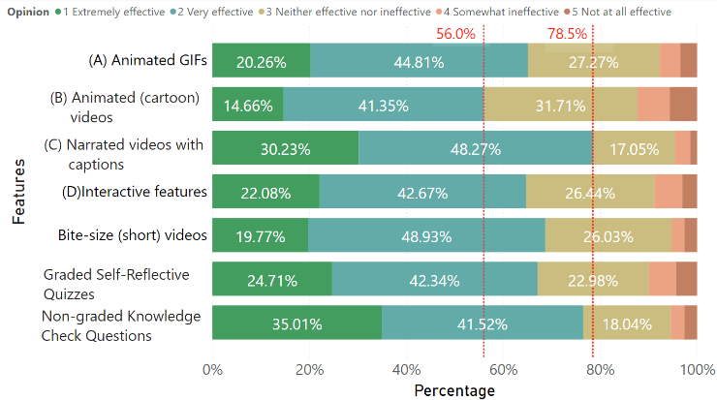

Figure 5. Students’ Responses to the Effectiveness of Interactive Multimedia Features, Bite-sized (short) Videos, Graded SRQs and Non-Graded Knowledge Check Questions for Question 6

Figure 6 shows the students’ preferences for the type of asynchronous lectures. Most students, 53.05%, preferred a mixture of recorded video lectures and interactive multimedia lectures, and 21.25% of them preferred recorded video lectures. Only 8.65% chose interactive multimedia lectures.

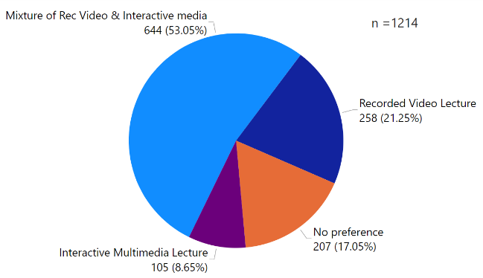

Figure 6. Students’ Overall Preference of Asynchronous Lectures for Question 10

Students’ responses to what they like and dislike about asynchronous lectures, and suggestions for improvement are shared here. Given the various open-ended responses received, these are broadly categorised with only the top three categories listed here.

The top three likes about asynchronous lectures

* Learning at own pace (55.2%)
* Ability to review content (17.4%)
* Convenience with no need to commute (7.3%)

The top three dislikes about asynchronous lectures

* Inability to pose questions or clear doubts and obtain clarification (27.4%)
* Lack of discipline and lose focus (11.0%)
* Difficulty in following content (6.8%)

The top three suggestions for improvements

* Human voice instead of text-to-speech for narration as it is less monotonous and livelier; teaching staff explain the concepts instead of reading from the slides (14.2%)
* Shorter videos (7.3%)
* Features with appropriate means to enable students to clarify their doubts while learning online (4.1%)

Other interesting suggestions are creating a chatbot to help students clarify their doubts and providing bounded notes bundled with the asynchronous content that requires students to fill in the blanks while learning online.

Figure 7 is a box plot of the AY2022/2023 Semester One GPA of the students and their time spent on a module per week. Eight students have withdrawn from the course. Thus, the total number of students has been reduced to 1206 for this analysis. The result showed that 90.5% of the students spent more than the allotted 1-hour self-directed learning time per module. Further analysis showed that for students who spent 2 to 3 hours or more, their median GPA was 3.27. For those who indicated 4 or more hours, the median was 3.58. Generally, it could be surmised that students spending more time learning the content would obtain better GPA. However, for those who indicated spending less than an hour, their median GPA was higher at 3.31 compared to the median GPA of 3.21 for those who reported time spent of 1 to 2 hours.

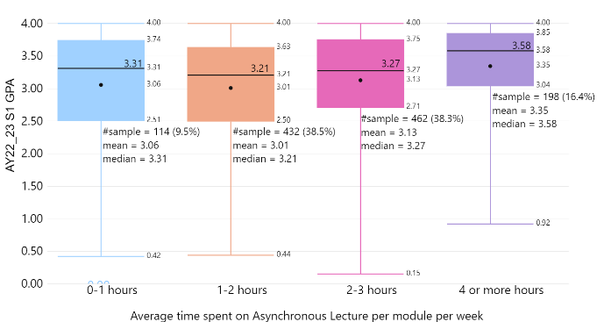Figure 7. Students’ Academic Year 2022/2023 Semester One GPA vs. Time Spent per Module per Week

**Discussion and recommendations**

The study shows that 67% or more of the students felt that the SRQs, knowledge check, and bite-sized videos, provided in the guidelines to staff for development, were either very effective or extremely effective for learning engineering concepts. Likewise, more than 56% of them indicated the same for interactive features.

The results further showed students’ preference (combined percentage of 61.3%) for the presence of the teaching staff as part of the recorded video lectures, with the teaching staff’s narration and added presence in the form of a thumbnail to show full body language. This preference aligns with the guiding principles of social cues for multimedia learning referred to earlier, which states that students learn better in an informal style (personalisation principles), preferring human voice (voice principles) and human gestures (embodiment principles).

This is further supported by the theory of “social presence” (Short et al., 1976), which explores the “sense of being with another” in an online environment and how the lecturer's social presence influences the overall student online experience. Students perceive a connection with this social person as being a physical “real” person in an electronic form and view them as social partners. This partnership will motivate the learner to put in more effort to understand what the instructors are saying, which results in better learning outcomes. Having the human aspect in recorded video lectures will also help address one of the top three dislikes of students of asynchronous lectures, that is, the use of computer-generated text-to-speech narration.

The literature cautions that animated and interactive graphics may not improve comprehension compared with their static equivalent (Mayer & Fiorella, 2022). Furthermore, such features should perhaps be included in situations to help novice learners through visualisation and mental representation of the processes. This seems to be reflected in the choice of only 8.65% of the students preferring interactive multimedia lectures for the entire asynchronous learning content.

However, in contrast to what has been offered by the principle of redundancy, that students learn better from graphics and narration than from graphics, narration, and onscreen text, 78.5% of the students rated the narrated video with captions as extremely effective or very effective for learning. A few students further suggested including captions or subtitles in the asynchronous lectures. This could be because engineering terms are not part of everyday spoken English, and so such captions included provide clarity. For instance, terms such as “phase” could be misunderstood as “face”, and “source” as “sauce”.

Given the demands of extended onscreen time on students, it is not surprising that only 7.91% of students opted for synchronous lectures. While Skylar (2009) suggested that students prefer synchronous lectures using web conferencing tools to text-based lectures, this stood in contrast to another finding that shared increased student burnout and decreased retention during synchronous lessons during the pandemic (Chen et al. ,2020). The school’s decision to replace all F2F lectures with asynchronous lectures and retain tutorials in the form of synchronous lessons of twenty students helped minimize the drawbacks of synchronous onscreen time and allowed better monitoring of students to minimize online stress.

**Recommendations for improvements in Asynchronous Lectures**

Asynchronous lectures provided by the school have the following features:

* Incorporate a lecturer’s own narration and/or physical appearance as part of recorded video lectures
* Include captions and sub-titles
* Bite-sized videos
* Presentation should have only key points
* Building of explanation by a lecturer with appropriate on-screen cues

Our findings reaffirm student preferences for the abovementioned features. Thus, it would be prudent to focus on including more of such features in future asynchronous content produced. For example, the students’ indicated preferences for recorded video lectures with lecturer’s presence and narration (Example 2) is a boon, as this method is less resource intensive. Teaching staff can record the lecture as though they are teaching on a videoconferencing platform or by using a screen recording software adding personalized prompts in the narration. They then further enhance these by adding captions and further editing if needed.

The school has many highly qualified lecturers with many years of experience teaching engineering, honed through many rounds of explaining, illustrating, and simplifying challenging concepts. Their treasure trove of tacit knowledge can be captured and preserved through the recording of their lectures, in the form of recorded video lectures, which would otherwise be lost either through retirement or resignation.

Future development work for engineering modules can incorporate the above recommendations, in addition to ensuring technical relevance and up-to-date contents. Students’ indicated wish for a means of getting their questions addressed while accessing the online content must be further explored to address the students’ wishes.

**Limitations of the study**

Self-reporting is an inherently biased measure of sampling. Pedagogy studies are especially vulnerable to such biases, as what students enjoy may not always correlate with what students benefit the most from. Since the study was concluded in an engineering school, the result may not be generalised across all fields of studies. Finally, surveyed students are not naïve to recorded video lectures and interactive multimedia contents, and their past experiences may have impacted their responses within the survey. Nevertheless, this study, is to the best of our ability, an accurate measure of the two goals this study set out to fulfil.

**Conclusion**

The COVID-19 crisis has resulted in the replacement of F2F lectures with asynchronous lectures in SEEE. The school has ensured that all modules offered, numbering more than 100, have met minimally, level 1 e-learning interactivity by September 2020. By December 2021, of these, 78 modules were further enhanced to include level 2 e-learning interactivity.

The results show a positive overall acceptance of the asynchronous learning contents created. Most of the students indicated a preference for recorded video lectures mixed with some interactive elements. For the recorded videos, the presence of the teaching staff needs to be enhanced through their own narration and thumbnail for the “social presence” desired by students while accessing the online contents.

Further exploration of the features of the current learning management system, Brightspace, in terms of collaborative tools and discussion board will be needed to address the students’ needs for their questions to be addressed while learning online.

The School is progressively improving the quality of the asynchronous lectures based on students’ feedback gathered. Further detailed in-depth analysis of students’ perceptions, according to the year of studies, will be considered for future work.

**References**

Chen, E., Kaczmarek, K., & Ohyama, H. (2020*).* Student perceptions of distance learning strategies during COVID-19. *Journal of dental education*, 10.1002/jdd.12339. Advance online publication. <https://doi.org/10.1002/jdd.12339>

Chen, H. T. M., & Thomas, M. (2020). Effects of lecture video styles on engagement and learning. *Educational Technology Research and Development*, 68(5), 2147-2164.

Choe, R. C., Scuric, Z., Eshkol, E., Cruser, S., Arndt, A., Cox, R., ... & Crosbie, R. H. (2019). Student satisfaction and learning outcomes in asynchronous online lecture videos. *CBE—Life Sciences Education*, 18(4), ar55.

Community Team. (n.d) Get to Know The 4 Levels of E-Learning. Retrieved from E-learning heroes: https://community.articulate.com/articles/get-to-know-the-3-levels-of-e-learning [Last Accessed 27 May 2022]

Crome, M., Rahman, A., Iversen, R. M., & Lührs, A. K. (2021). Synchronous vs. asynchronous education: Questionnaire-based survey in dental medicine during the COVID-19 pandemic. *Dtsch Zahnärztl Z Int*, 3, 207-215.

Draus, P., Curran, M.J., & Trempus, M.S. (2014). The Influence of Instructor-Generated Video Content on Student Satisfaction with and Engagement in Asynchronous Online Classes.

Evans, C., & Gibbons, N. J. (2007). The interactivity effect in multimedia learning. *Computers & Education*, 49(4), 1147-1160.

Ha, Y., & Im, H. (2020). The Role of an Interactive Visual Learning Tool and its Personalizability in Online Learning: Flow Experience. *Online Learning*, 24(1), 205-226.

Mayer, R., & Fiorella, L. (Eds.). (2022). *The Cambridge Handbook of Multimedia Learning* (3rd ed., Cambridge Handbooks in Psychology). Cambridge: Cambridge University Press. doi:10.1017/9781108894333

Short, J., Williams, E., & Christie, B. (1976). *The social psychology of telecommunications*. London: John Wiley & Sons.

Skylar, A. A. (2009). A comparison of asynchronous online text-based lectures and synchronous interactive web conferencing lectures. *Issues in Teacher education*, 18(2), 69-84.